

**Updates**

We did not update any of the personas and use cases in this assignment as we did not receive little feedback for these sections in the last assignment and we got high marks. So, the description, personas and use cases are copy-and-pasted from assignment 1.

**Description – PeerWise**

**Existing Solutions**

There are a number of systems that are similar to PeerWise like Kahoot, GoSoapBox, and Wooclap.

All these services have a large sign up/sign in banner at the top of their home page so that it’s the first thing that you see when you first visit the website. Below this they show people that have used their service. Each persons’ demographics and occupation are shown as well therefore, people visiting the website find it easier to identify whether they would use it since they can see if they are similar to the userbase. There are also quotes from these users explaining their positive experiences with it. This means visitors of the site will be more likely to use it.

These services are similar to PeerWise because each one is catered for students and teachers. They all innovate traditional learning and make learning more interactive and fun for the students. They also have a much more streamlined registration page and have a tutorial on how to sign up. For example, GoSoapBox and Kahoot has a guide on how to get started right after signing up while PeerWise doesn’t. Each service also has a quicker way to register because the username, password and email fields are all on the same page. In comparison to PeerWise where you need to enter your school/institution, click on the register link and then the fields for each registration detail (username, password, course ID and identifier) are shown on separate pages. In particular, the most inconvenient aspect about PeerWise’s registration is that you can only find out your course ID and identifier from your course coordinator.

These services also follow a minimalist design, reducing the amount of text shown on the screen to make sure the user is not overwhelmed with information. And each given text is isolated from other nearby text via a border or container which helps the user to take the information in at a good pace. This is shown in Kahoot’s home page after you login. These services also are more preferable to PeerWise in terms of creating a question or quiz. Take Wooclap for example, their way of creating questions and quizzes gives the user more freedom to customize questions and quizzes since they can have more multiple choice answers than PeerWise which only has 5 at a maximum. Wooclap, unlike PeerWise, allows questions to be in different formats such as polls, open questions, fill in the blank questions etc. These formats are presented in a drop-down list making it convenient for the user to change the format of their question.

**Business Objectives**

PeerWise is a tool instructors (secondary school teachers or university course coordinators) use to set up courses which students can join. Students can then create questions which other students can answer. Additionally, students can rate questions once they have answered them and can filter questions by their topic. They can also start quizzes which are an assortment of questions they have already answered. All these features contribute to PeerWise’s purpose which is to encourage student collaborative learning to ensure that the students have a deeper understanding of the course material.

The problem with PeerWise is that it has an outdated and inconvenient interface. This is shown by the registration process which has a page for each registration step. The login process is also inefficient as you have to enter in your school/institution before being able to log in. Visually PeerWise also looks outdated and unappealing when compared to modern services/products. This is because of its outdated icons, lack of stylisation and basic backgrounds.

To solve this issue a modernised interface and design is needed. Having this will make it easier for students to use PeerWise and they will be more incentivised to continue using it in the future. They will also be more likely to recommend it to family and friends. This will lead to a larger user-base that has more returning users (users that revisit PeerWise). It will also help with the key business objectives of PeerWise (listed below):

· Instructors can facilitate collaborative student learning through course creation and activation

· Students can have a deeper understanding of topics by explaining and discussing questions and their answers

· PeerWise has an easy-to-use, convenient and modernised interface and has an aesthetically pleasing design

**Importance to StakeHolders**

PeerWise is important as it gives students another way to learn course material. If students keep learning in the same way they are more likely to become demotivated and unenthusiastic about learning so they will find it harder to take in course material. This might lead them to submitting lower quality assignments/projects and/or performing worse in exams. PeerWise is also important because it allows students to learn from each other and they can give each other different views and opinions on topics which they may not have thought about. This results in a much deeper understanding of the topic.

PeerWise also helps teachers because it ensures that students aren’t relying solo on the teachers perspective of the topic. Having only one perspective of the topic can potentially create biases and can limit how well students can comprehend the material. This in turn may affect the students grades therefore it should be avoided.

This also alleviates some of the teachers and professors workload by getting the students to help each other on topics that they are confused about, and the teacher won’t need to spend their time helping each troubled student individually. This means that teachers will be able to teach more topics to the students and/or dive deeper into the topics they are already teaching.

**Model Overview**

**Persona Model Process**Creating our persona model was a complex process and consisted of many steps. These steps were:

* Analysing the GenderMag persona generation technique. Though we did not directly use this technique some of our sections in our Persona were inspired from it like Background, Skills, Demographics and Motivations. GenderMag also taught us that including a photo of the person the persona is representing is a good idea.
* Reading pages 61 to 70 from the book “About face: the essentials of interaction design”. This material helped us develop a deeper understanding of personas and the process of creating personas. This is because it covered important information like the usefulness of personas, how to create a realistic persona and the preliminary steps to create personas such as research.
* Doing further research by reading online articles and watching informative videos helped us come up with more persona sections which were goals, needs and expectations,
* Now that we had clearly defined our personas structure, we defined the scope of people that would use PeerWise which is any gender, ages ranging from 15-50 and their occupation being a secondary school student, a secondary school teacher, a university course coordinator/lecturer or a university student.
* From here we split the userbase based on a key, defining trait which is their occupation, we did this by having each persona represent an occupation. Then we made sure both genders were represented by having three male personas and one female and we determined the age of the personas based on the most likely age of someone in their occupation.
* After determining the persona’s demographics we focused on giving them traits, goals and aspirations, a realistic photo, detailed backgrounds, strengths and weakness (shown by their skills) and other information defined by our other sections. When creating the personas, we always tried to make them unique and significantly different from each other to cover a wider range of the userbase.
* Once we established all of our personas details we looked online for tools that could help us make and stylise these personas. We found UXPressia ([www.uxpressia.com](http://www.uxpressia.com/)) which is a fantastic tool because sections that are common to find in personas like background, motivations etc. can easily be added and to the persona. Additionally, custom sections can be added as well. These sections can be rearranged and text formatting options are available as well. The best part about this tool is it made our personas look very stylish.
* When we used this tool to make our personas, we included sections we already agreed on having (e.g. Background, Skills, Demographics etc.) but we also used pre-defined sections it had (Frustrations, Quote, Challenges and Context/Environment). We did this because we felt these additional sections made our personas more realistic and believable and strengthened the connection between them and PeerWise.
* All the personas we created were included in our persona model and we decided to focus on all of these personas in the rest of the report because each persona represents an important part of the userbase and gives a good coverage of the system requirements.
* Next we had to determine what tasks the personas would perform when using PeerWise. We figured the best way to do this was to put ourselves in our personas shoes and use PeerWise. We created accounts via registration, joined the SWEN303 Course and used all of PeerWise features and functionality. We broke these features and functionality down into individual tasks and looked at the relationship between these tasks. From there we represented these tasks with their relationships to each other in the persona model.
* We focused on most of the tasks shown in our persona model as these tasks represented critical and/or necessary features/functionality that is used quite frequently. We didn’t choose to focus on the task “logging in” in the rest of the report as we considered this task to be too small to be a standalone use-case scenario so instead we included it as an instrumental task to another one of our use-case scenarios (“starting a quiz on mobile”). Account is just an entity representing the users account, it is not a task, so there is no need to analyse it. We also decided to not focus on the task “changing from mobile view to desktop view”, since desktop view is the default view. Some of the use-case scenarios we focus on later in the report have multiple tasks (these tasks are shown in the persona model) either because they are very small on their own or they are naturally related to each other. For example, we have a use-case scenario where the user answers a question and rates the question because a user can only rate a question after they answer it, so these two tasks are inherently linked.

**Prioritising the tasks**We prioritised the use case scenarios by looking at how critical they were to the systems functions and also factoring in the purpose of PeerWise. For example, to be able to use the majority of PeerWise’s functions the user needs to register for an account. Therefore registration is quite an important use-case scenario however, it is not the most important because it does not fit the purpose of PeerWise. This is because users are not visiting this service to register for an account, they are here to further their learning by creating questions and answering questions.

Those that are less critical to the systems functions would be less of a priority especially if they are not directly affecting the purpose of the system. Viewing badges is a good example of this because though it does incentive users to keep using PeerWise viewing badges doesn’t match the purpose of PeerWise and if badges were to be removed from PeerWise the system would still be able to function perfectly fine.

We also took into account how frequently each user would perform the task/use-case scenario. For example, the act of giving feedback has a low priority since most users won’t bother providing feedback because they do not feel the need to (they have no major issues with using PeerWise). So, scenarios that have a higher chance of occurring like creating or editing a question have a higher priority. Frequency was determined by how many people interacted with the task. For example, the viewing leaderboards task was only done by those who were interested of the statistics in the course.

**Personas (from most important to least important)**August did this persona

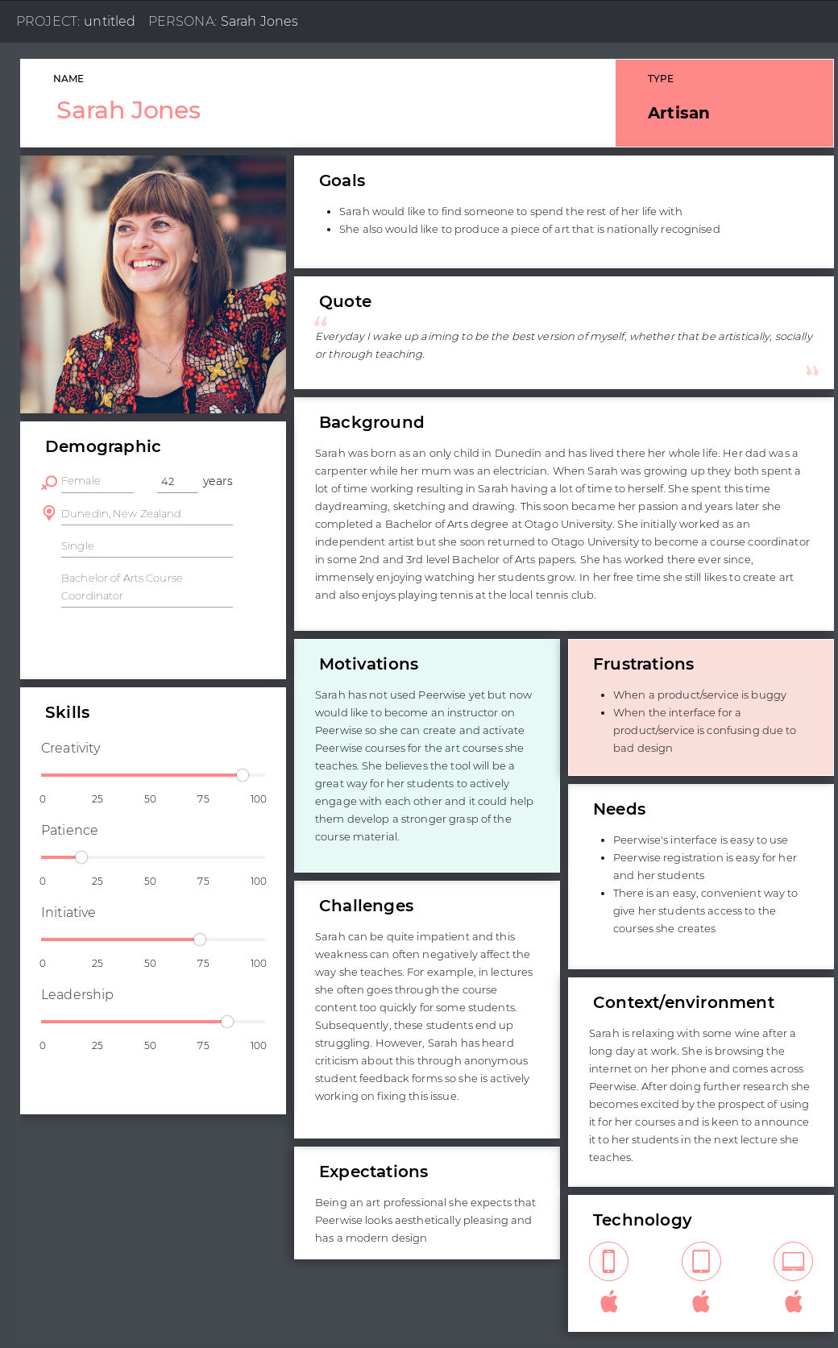

August did this persona  
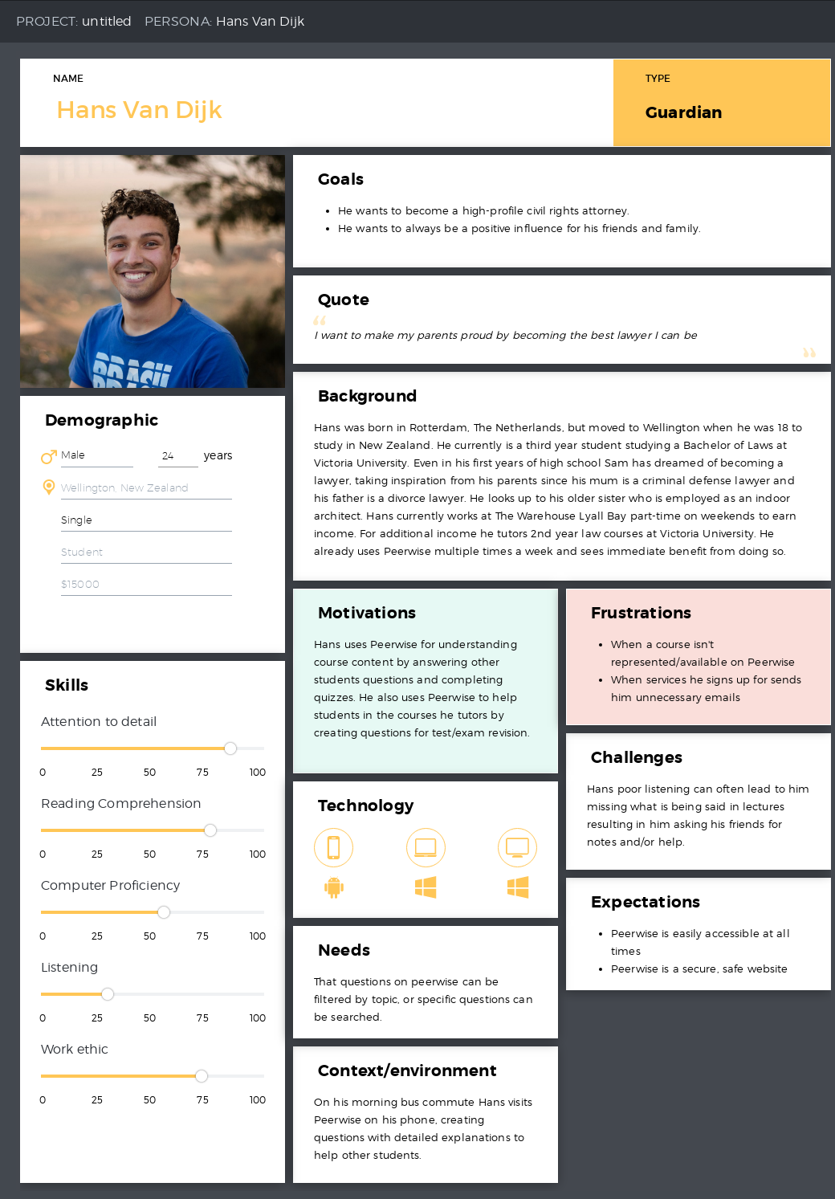

Nyle did this persona  
  
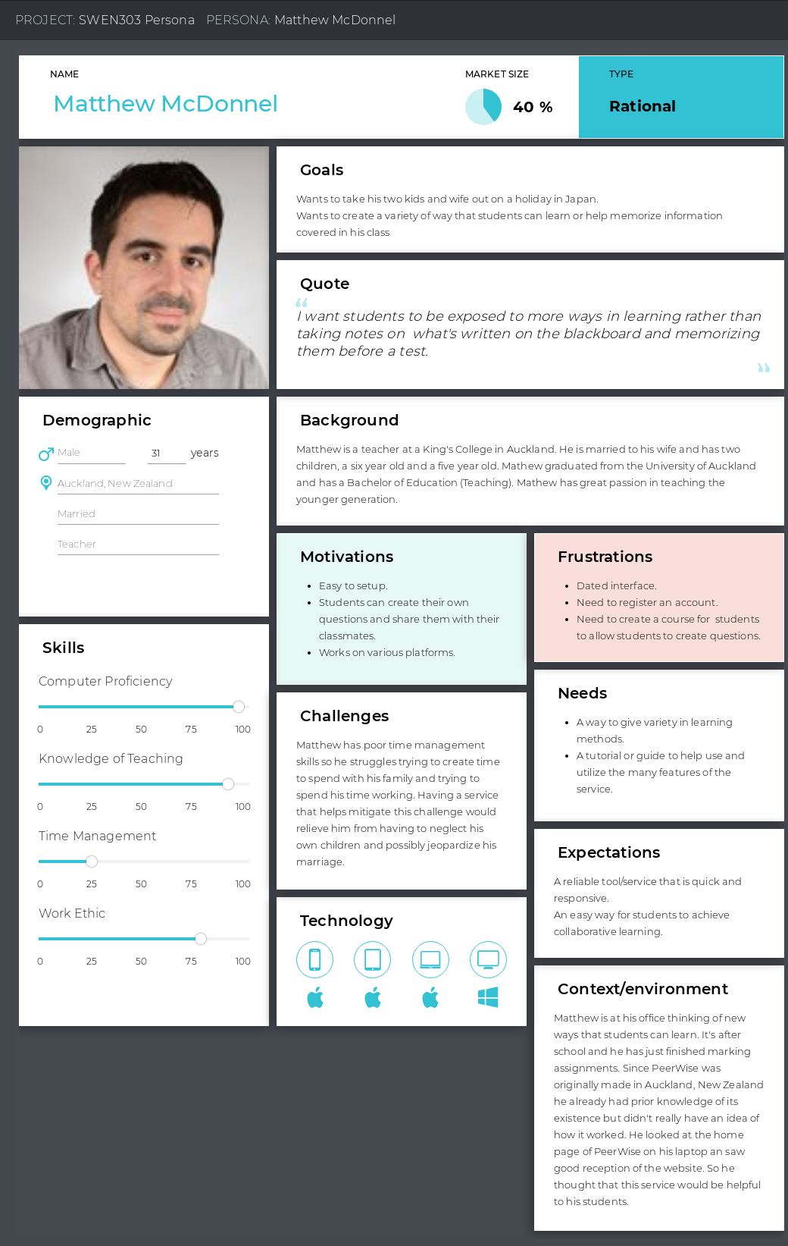

Nyle did this persona

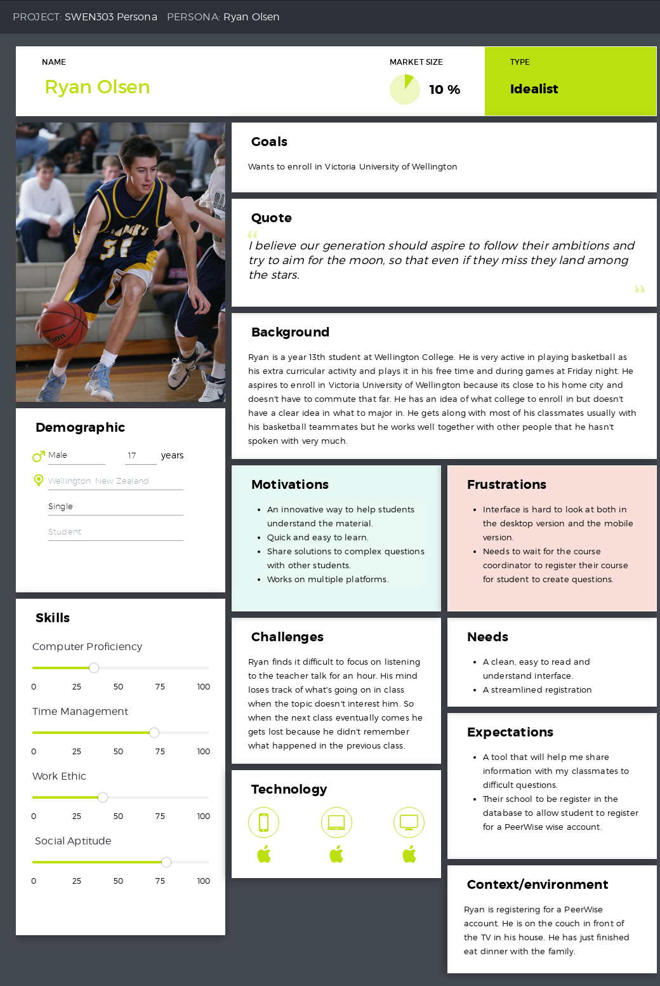

**Justification of persona ranking**

**Sarah Jones (written by August)**Students are unable to use any of PeerWise’s features without joining a course. Courses are created by instructors (course co-ordinators or secondary school teachers). So, heavily prioritising the group of people that allow other parts of the userbase to use the service is necessary. Sarah’s expectations for PeerWise also matches one of PeerWise’s business objectives which is to have a modern design and to look aesthetically pleasing.  
  
**Hans Van Dijk (written by August)**

University students (and to a lesser extent university course coordinators) make up most of the userbase. This is shown when you search for a school/institution on PeerWise since only a small fraction of New Zealand secondary schools shows up, proving that most secondary schools don’t use PeerWise. On the other hand, when you search for a New Zealand tertiary institution it will always come up. Also, as a tutor he has another important use for the system which is helping the students he tutors. He also has expectations for PeerWise that facilitate good design, such as PeerWise being a safe, secure website.

**Matthew (written by Nyle)**Matthew is a secondary school teacher and is looking for a better way to help students learn the material he teaches in his classes. Like with Sarah, the students are reliant on the teachers to use the service so secondary school teachers are more important than secondary school students. Matthew also has trouble with managing his time so using this service will help decrease his workload because he won’t need to attend to each individual student when they require assistance, by letting other students help each other.

**Ryan (written by Nyle)**Ryan gets lost easily in class and using this service would help him understand the material that he missed out on or that he doesn’t really quite get. This persona is the least important because secondary schools take a smaller fraction of the user base and are reliant on other parts of the user base to make use of the service.

**Scenarios and Use Cases (from most to least important)**

**#1 Creating a question (created by August) – Hans, Ryan**

|  |  |
| --- | --- |
| **User Intention (assuming the user on the questions page)** | **System Requirements** |
| Selects create new question option |  |
|  | Display new page with a question title field, answers field, explanation field and topic options |
|  | Display preview or save as draft options |
| User fills in fields, selects which answer is correct and picks a topic. |  |
| User chooses save as draft option |  |
|  | Display created questions page with option to edit draft |
| User chooses edit draft option |  |
|  | Display the draft |
|  | Display preview or save as draft options |
| User edits a field and chooses display as preview |  |
|  | Shows preview of question |
|  | Shows make changes and save question options |
| User chooses save question option |  |
|  | Goes back to showing all the questions the user has created |

**#2 Answering Questions and Rating Questions (created by Nyle) – Hans, Ryan**

|  |  |
| --- | --- |
| **User Intention** | **System Requirements** |
| Navigate to unanswered questions page |  |
|  | Show all unanswered questions |
| Choose a question |  |
|  | Show the question page |
| Choose answer |  |
|  | Show chosen answer page consisting of  the answer field, explanation field, topic field and comment field |
| Choose to write/update an explanation |  |
|  | Publish explanation and update the chosen answer page |
| Choose to write a comment |  |
|  | Publish comment and update the chosen answer page |
| Choose difficulty rating of the question |  |
|  | Highlight choice |
| Choose quality rating of the question |  |
|  | Highlight choice |
| Submit rating and return to question list or go to a random question |  |
|  | Show question list page or show random question |

**#3 Course Creation and Course Activation (created by August) – Sarah, Matthew**

|  |  |
| --- | --- |
| **User Intention (Assuming they have an instructor account)** | **System Requirements** |
| Chooses “Create a new course” option |  |
|  | New page is displayed which has a Course name field |
| Enters and submits a course name |  |
|  | Display page asking user to confirm that course details are correct |
| User confirms course details |  |
|  | Home page is displayed showing the newly created course with its Course ID and an option to activate the course by uploading student identifiers |
| User chooses activate course option |  |
|  | Shows identifiers field and a field for a text prompt that gets displayed when students need to enter their identifier for a course |
|  | Show “update identifier list and prompt” option |
| User enters identifiers in identifiers field and edits the text prompt field |  |
| User chooses update identifier list and prompt option |  |
|  | Shows update message and returns to the identifiers & prompt page |

**#4 Requesting an instructor account (created by Nyle) – Sarah, Matthew**

|  |  |
| --- | --- |
| **User Intention** | **System Requirements** |
| Request an instructor account |  |
|  | Show the instructor account registration page |
| Enter in name, username, work email and institution/school |  |
| Submit |  |
|  | Send code to email address to verify account creation |
|  | Show code verification page |
| Enter code |  |
|  | Show request completion page |

**#5 Registering a student account (created by August) – Hans, Ryan**

|  |  |
| --- | --- |
| **User Intention** | **System Requirements** |
| Enter school/institution |  |
|  | Show PeerWise welcome page with login fields and the registration link |
| Navigates to registration page |  |
| Begins registration |  |
|  | Shows username page with username field |
| Enters username |  |
| Submits username |  |
|  | Checks password is valid |
|  | Shows password page with password fields |
| Enters password |  |
| Confirms password |  |
| Submit password |  |
|  | Check passwords match |
|  | Shows course ID page with course ID field |
| Enters and submits course ID |  |
|  | Checks course ID is valid |
|  | Shows identifier page with identifier field |
| Enters and submits identifier |  |
|  | Checks identifier is valid |
|  | Shows home page |

**#6 Editing questions (created by August) – Hans, Ryan**

|  |  |
| --- | --- |
| **User Intention (assuming they have created a question)** | **System Requirements** |
| Navigate to questions page |  |
|  | Show a list of user’s created questions |
| Selects a created question |  |
|  | Shows question statistics and details like the title, answers, explanation etc. |
|  | Shows edit question option |
| Chooses edit question option |  |
|  | Shows editable fields like title, answers, explanation, topics |
|  | Shows preview option and draft option |
| Edits these fields |  |
| Previews edited question |  |
|  | Shows preview |
|  | Shows “make changes” and “save question” options |
| Saves question |  |
|  | Goes back to showing all the questions the user has created |

**#7 Deleting questions (created by Nyle) – Hans, Ryan**

|  |  |
| --- | --- |
| **User Intention** | **System Requirements** |
| Navigate to user’s created questions |  |
|  | Show a list of user’s created questions |
| Choose a question |  |
|  | Display new page with a question title field, answers field, explanation field and topic options |
| Choose to delete the question |  |
|  | Show warning to alert the user of deleting the question |
| User chooses to delete the question |  |
|  | Delete the question from the database and show the user’s questions page |

**#8 Quiz on mobile (created by Nyle) – Hans, Ryan**

|  |  |
| --- | --- |
| **User Intention** | **System Requirements** |
| Selects institution/school from drop-down list |  |
|  | Show login page with login fields |
| Enters in username and password |  |
|  | Checks that the username and password is in database |
|  | Show home page |
| Choose to change view from desktop or mobile |  |
|  | Switch view from desktop to mobile |
| Start a quiz |  |
|  | Show quiz page with the quiz categories |
| Choose a valid category |  |
|  | Show 1st question |
| Choose an answer | (Repeat until the end of quiz) |
|  | Show result and answer |
| Proceed to next question |  |
|  | If final question then show results page otherwise show next question (Repeat until the end of quiz) |
| Chooses to log out |  |
|  | Logout the user and show login page |

**#9 Verifying email address (created by Nyle) - Hans, Ryan, Matthew**

|  |  |
| --- | --- |
| **User Intention (assuming they are logged in and are on the home page)** | **System Requirements** |
| Navigate from home page to email verification page |  |
|  | Show the email verification page |
| Enter email address |  |
|  | Send the verification code to the given email address |
|  | Shows verification code page |
| Enter verification code |  |
|  | Check if verification code matches |
|  | If not matching then alert the user that the code provided was incorrect |
|  | If code matches then show the home page |

**#10 Resetting password (created by August) - Hans**

|  |  |
| --- | --- |
| **User Intention (assuming they have verified their email address)** | **System Requirements** |
| Navigate from home page to change password page |  |
|  | Show change password page with password fields |
| Enters password |  |
| Confirms password |  |
| Submits password |  |
|  | Changes user password |
|  | Displays home page |

**#11 Filtering Question (created by Nyle) - Hans, Ryan**

|  |  |
| --- | --- |
| **User Intention** | **System Requirements** |
| Navigate to one of the questions page |  |
|  | Show a list of questions |
| Choose to filter out the questions |  |
|  | Show a list of topics |
| Choose one topic |  |
|  | Update list and only show questions related to that topic |

**#12 Joining a Course (created by Nyle)- Hans**

|  |  |
| --- | --- |
| **User Intention** | **System Requirements** |
| Join a course |  |
|  | Show join course page |
| Enter course ID |  |
|  | Check if course ID is valid |
|  | If not alert the user of invalid course ID |
|  | If valid show identifier page |
| Enter identifier |  |
|  | Check if identifier is valid |
|  | If not alert the user of invalid identifier |
|  | If valid show home page |

**#13 Provide Feedback (created by Nyle) - Sarah, Matthew**

|  |  |
| --- | --- |
| **User Intention** | **System Requirements** |
| Choose to provide feedback |  |
|  | Show feedback page |
| Enter feedback |  |
| Choose to remain anonymous |  |
| Submit feedback |  |
|  | Show appreciation for feedback page |

**#14 Viewing leaderboards (created by August) - Sarah, Matthew**

|  |  |
| --- | --- |
| **User Intention** | **System Requirements** |
| Navigate to leaderboards page |  |
|  | Calculate leaderboard data/statistics for the course |
|  | Show leaderboard page, consisting of sections such as Highest Reputation Scores, Highest Answer Scores, Top Rated Questions |

**#15 Viewing badges (created by August) - Ryan**

|  |  |
| --- | --- |
| **User Intention (assuming they are logged in and are on the course page)** | **System Requirements** |
| Navigate to badges page |  |
|  | Show badges page, consisting of: Basic badges, Standard badges, Elite badges and badges earned compared to other students |

**Justification of Use Case Ranking**

**#1 Creating questions – Written by August**

The core functionality of PeerWise is built around questions and the users interaction with them. The key point of PeerWise is for users, primarily students, to use it as a tool for learning and revising course content. This is achieved through answering quality questions (questions that have detailed explanations and realistic answers). However, users only have the ability to answer these questions if there is functionality in place for creating the questions. Therefore creating questions is the most important use-case scenario for PeerWise.

**#2 Answering questions and rating questions – Written by August**

As mentioned in the ranking explanation for the “Creating questions” use-case scenario, users learn and revise course content (the purpose of PeerWise) through answering other users' questions. Another way of revising course content is by completing quizzes however, the quizzes are generated based on the questions you have already answered and there is a requirement of answering 10 questions to start a quiz so, answering questions is still the main way of achieving the purpose of PeerWise. Rating questions, another feature of PeerWise, allows for user-based moderation of questions and can help identify good or bad questions.

**#3 Course Creation and Course Activation – Written by August**

Being able to create and activate courses is another key piece of functionality for PeerWise. All the other main functionality of PeerWise is dependent on course creation and activation. This is because to register for a standard account you must join a course and registering gives you access to all the other features/functionality of PeerWise. Activating a course by setting identifiers for the course is equally as important as creating it or else other users will not be able to join the course (since they do this by submitting their identifier). Course creation and activation is particularly important to course co-ordinators/secondary school teachers as this will be the main feature they will use.

**#4 Requesting an instructor account – Written by August**

As mentioned in the previous ranking justification users can’t do many tasks until they have registered for the website. For instructors to register they have to request an account first. Instructor accounts have the ability to create and activate courses while other (standard) accounts do not therefore the registration for instructor accounts is more important than the registration for standard accounts.

**#5 Registering a standard account – Written by August**

Registering a standard account is still important as most users using PeerWise will have a standard account. Requiring users to have an account gives each user an identity and allows data such as questions they have created, questions they have answered and statistics to be linked to their account, so the process of making an account is critical.

**#6 Editing Questions – Written by August**

Another task users can do is editing questions. This is important because users will often edit their questions for reasons such as fixing grammatical errors, improving explanations, making the question title clearer etc. Editing questions is more important than deleting questions because users are more likely to edit a question than delete a question. Also, editing a question often is more preferable than deleting it as the information linked to the question (like statistics on what user chose what answer) will not be deleted as well.

**#7 Deleting Questions – Written by August**

PeerWise allows users to delete questions that they have created. This feature is fairly important because it allows users to remove their questions if they have made a significant mistake (e.g. the question isn’t appropriate for the course). Deleting questions also allows old, outdated questions to be removed which helps the course question page become less cluttered, making it easier for students to find questions they’ll find helpful.

**#8 Quiz on mobile – Written by Nyle**

This is an important use case because this allows users to use PeerWise on mobile which means PeerWise is a lot more accessible and convenient as they can use it while they are on the move (e.g. travelling/commuting). In this age where the majority of people own a smartphone this use case will be relevant to most of the user base. Creating quizzes makes it easier for students to answer multiple questions in a row and it is a convenient way for them to revise all the content they have learnt from PeerWise.

**#9 Verifying email address – Written by Nyle**Verifying the user's email address is an important use case because it allows a safe, secure way to send the users password in case the user can’t access their account because they’ve forgotten their password. If the user has verified their email then the service can safely send the instructions to reset their password via email so that the user can access their account.

**#10 Resetting password – Written by Nyle**This use case is important because people often forget their passwords. People likely care more about their security rather than their convenience. Therefore, they use a long password that is hard to remember rather than a short password that is easy to remember and is easy to crack. This is more important than the use cases below because a password is essential to be able to access your account, and an account is essential to use PeerWise

**#11 Filtering questions – Written by Nyle**This use case is only important when there is a lot of questions that have been created for the course and it will only apply if PeerWise is heavily used. But when the questions list is only one or two pages the user can just read the question titles instead. This would only be frequently used when there is large participation within the course and would only suit users that like to find questions quickly. It is more important than the use cases below because it does offer a way to make the service more convenient for some users.

**#12 Joining a course – Written by Nyle**

Joining a course is a use case that will only be used when the user has more than one university course/secondary school subject that uses PeerWise. This is unlikely to be the case for most people unless the service is heavily used within the institution. Even if the user has multiple courses to join, they (university students) would likely only use it 1-3 times every trimester. So, this scenario is not very frequent.

**#13 Provide feedback – Written by Nyle**

Providing feedback is helpful to PeerWise but it is not vital. Users also have been given an alternative option for providing feedback that is likely more convenient to them which is Twitter so, having a feedback interface created within the system is less important and will likely be less used in comparison to the alternative. Even if this is used people will most likely only give feedback once.

**#14 Viewing leaderboards – Written by Nyle**

This is one of the least important use cases because this is not what the purpose of the service (PeerWise) is for. Those who are more competitive will be more enthusiastic about using PeerWise since they have a direct way of comparing themselves to their peers, but it will not be the reason to why they’re using this service. This use case will only help keep users using the service while they actually fulfil the main reason for visiting this website which is to answer and create questions to help with their learning. Also, the only users that will view this interface would be teachers and students that are competitive/care about statistics.

**#15 Viewing badges – Written by Nyle**

Viewing badges is the least important use case because they are not essential to the core purpose of the website. They do provide the users with some degree of satisfaction when they are given a badge for completing a task. But since the user base is related to universities and secondary schools, they are not focused on acquiring badges but rather learning material that has been covered in their classes therefore, very few people would be involved in this scenario.

**Design**

**Colour Palette  
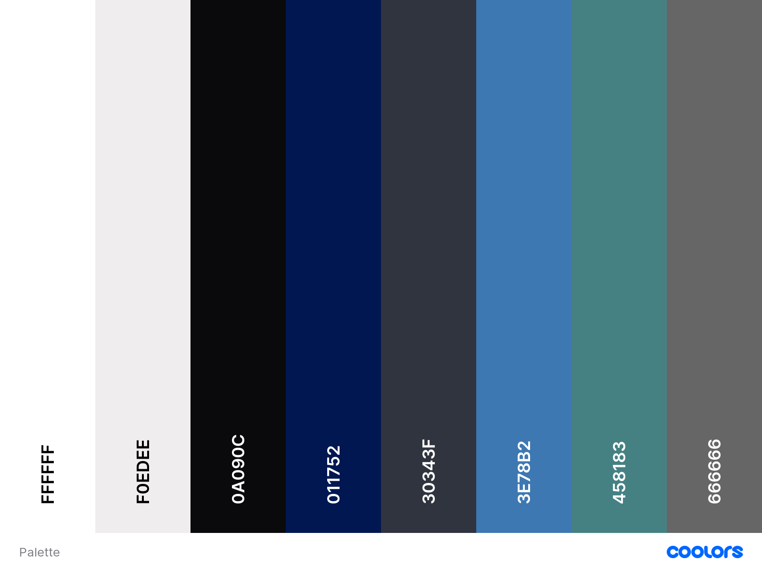**

We decided to have a fairly similar colour scheme to the colour scheme of PeerWises’ old design (blue, white and grey) so users would be able to adjust to the new colour scheme quicker however, we added in teal to add a bit of variety. Though we use all colours quite a lot the primary colours are white (FFFFFF) and a medium blue (3E78B2). We use the teal (458183) sparingly and black (0A090C) is used a lot. The greys are used occasionally, mainly for highlighting/indicating when a user is hovering over a component. We also chose to include a navy blue colour as this colour is often used in business/professional websites.

**Fonts in Balsamiq**

We made all our designs in Balsamiq which doesn’t have the ability to choose different fonts so all our text has the ‘Comic Sans’ font unfortunately. If we were using a different tool we would use multiple (and better) fonts.

**Balsamiq Wireframes**

All our wireframes can be found in our Balsamiq file in our gitlab repository (<https://gitlab.ecs.vuw.ac.nz/onginyle/swen303-assignment-2>)

**Task Coverage and Persona Needs**

We made designs for all use-cases (tasks) we defined earlie. However, we did not fully cover the ‘quiz on mobile’ use-case because even though we covered creating a quiz we did not cover doing it on mobile. The only difference between creating a quiz on mobile compared to desktop is the design would be suited for mobile devices. Apart from this minor part of one of our use-cases we have 100% task (use-case) coverage. Some of our designs don’t relate to any use-case and that’s because these designs are pages that are part of the structure of the website (therefore essential to cover) but aren’t directly involved in any use-case. We also made sure to cater towards our persona needs by making the interface easier to use, removing unnecessary and confusing functions (e.g. users being able to change their answer after seeing the right answer) and made the website more colorful. We also made the website flow together smoothly by including a navigation bar and made PeerWise more aesthetically pleasing by having a more spacious layout.

**Navigation Bar, Footer and Logo**

All pages shown below have a banner and most also have a navigation bar and a footer. The banner includes PeerWises’ new logo. I changed the logo because the old one was low resolution and did not fit PeerWise’s new colour scheme and had an ugly WordArt reflection effect. The new logo still has resemblance to the old logo so the change is easier for users to take in. Below is a picture of the old logo so you can easily see the difference.



We chose black and white for our navigation bar and footer colours as these colours have high contrast and are neutral colours. The footer includes social media links to promote PeerWise and also has an option to change the view from desktop to mobile or vice-versa (with the current view being indicated).

**PeerWise Homepage**

**Hans, Matthew, Sarah, and Ryan**

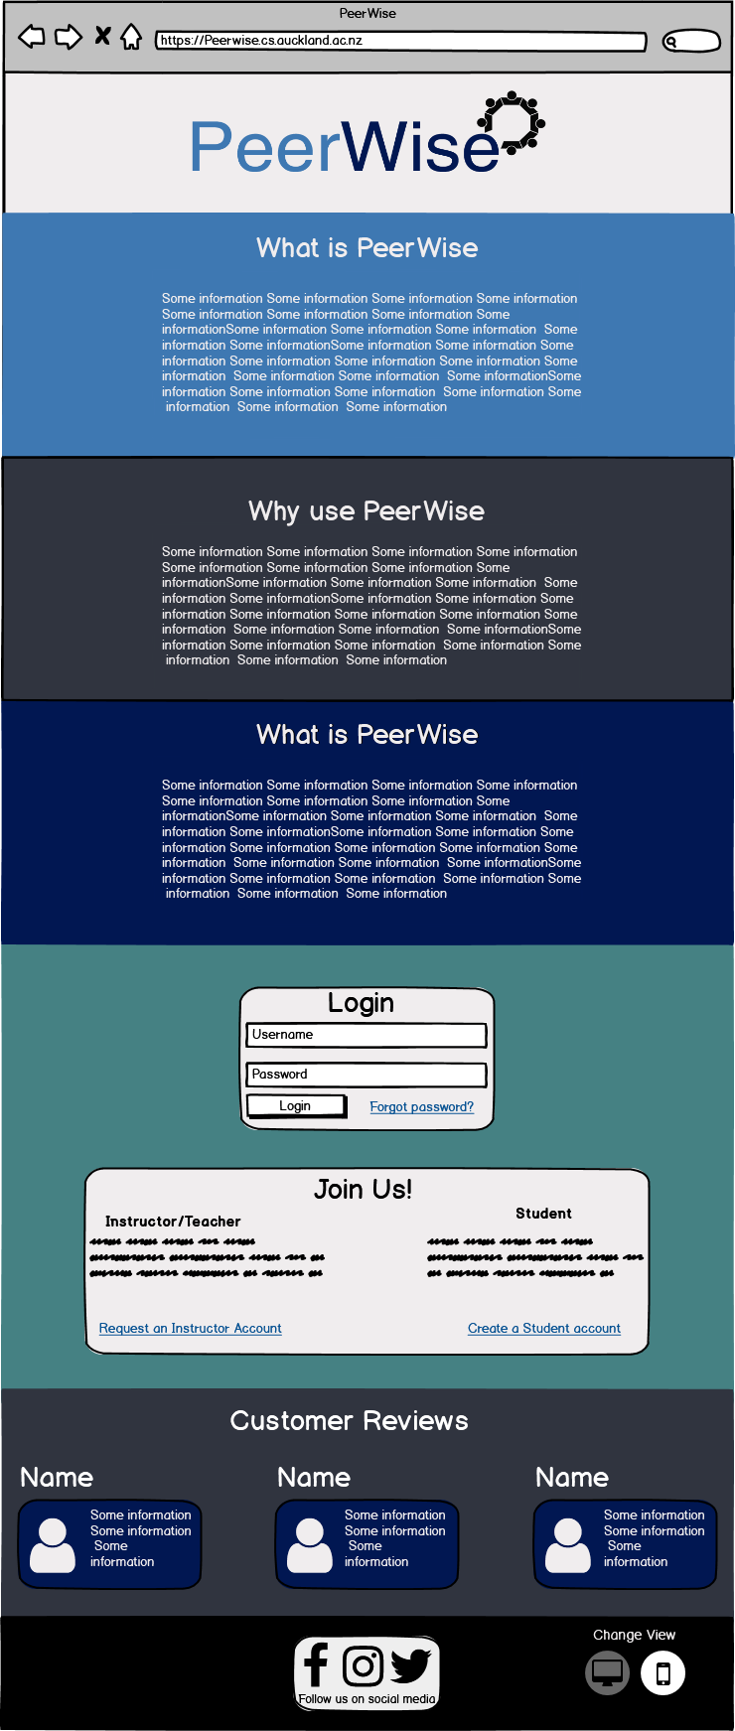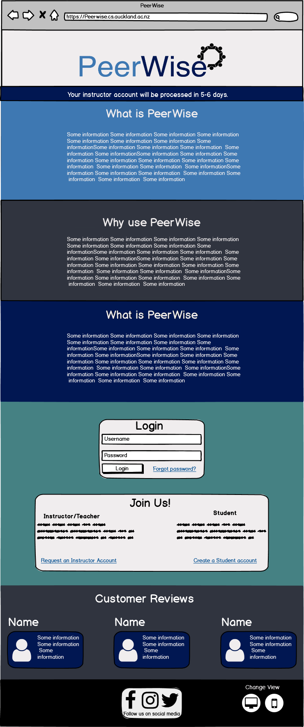

This is the homepage of the website so this will be the first thing that users see. Since we need to create a good first impression our homepage needs to be eye catching and informative. The first three sections of the homepage shows the user what PeerWise is and why use it. Each section is separated with a different colour, this will help the user’s eyes focus on that section alone and their eyes won’t wander off to the other sections. Users also need to scroll down to reach each section as the entire page will not fit in one screen. We used dark and cool colours so that the user can read the text without straining their eyes with a bright background. Allowing the users eyes to suffer less fatigue will help them read the information without interruption. The more information they get will help determine if they will use PeerWise or not.

After the information sections the user is then presented with a login or register section. This section allows the user to choose to either present their username and password to login, register a student/instructor account, or if they have forgotten their password choose to reset their password all in one page. Resetting passwords are common among websites that contain authentication functions, because many users tend to forget their passwords if they have multiple accounts with different passwords or their password is difficult to remember. This may apply to senior teachers that have difficulties remembering things.

Registering an account is vital to this web service because an account is required to make use of any of the website's features. The user can choose to either have a regular account or they can request for an instructor account. After the login/register section comes the customer reviews and the footer of the page. The customer reviews will mainly display positive reactions to promote this service. The footer of the page contains social media links and the option to switch between mobile and desktop view. There is also a message shown at the top of the homepage when a user applies for an instructor account.

**PeerWise Register Page**

**Hans, Matthew, Sarah, and Ryan (Use-case #5)**

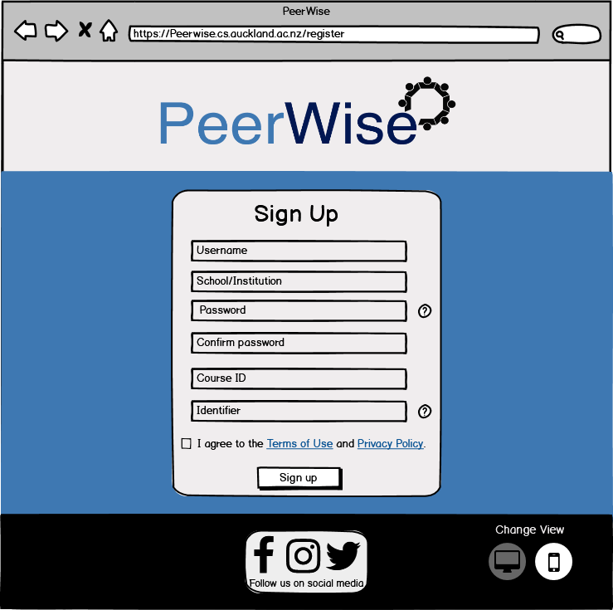

The registration page is kept simple and all the necessary registration fields are in one page. This will streamline the registration process so that users do not have to enter a new page for each field that they fill in. The fields for registration are username, school/institution, password and confirmation, course id and an identifier. Users have a question mark button that they can click to get more information about the field. All the fields need to be filled in and then the user needs to check the box to be able to sign up. Since this is just one section, all that's needed is one background colour. We chose the light blue to keep a consistent pattern to the first colour below the logo.

We also added a requirement to click on a box to agree to Terms of Use and Privacy Policy before proceeding. This was originally not in our use cases.This page is more relevant to the student roles as they need an account to use the features of PeerWise. Teacher’s have another page to request for an instructor account.

**PeerWise Instructor Register Page**

**Sarah, and Matthew(Use-case #4)**

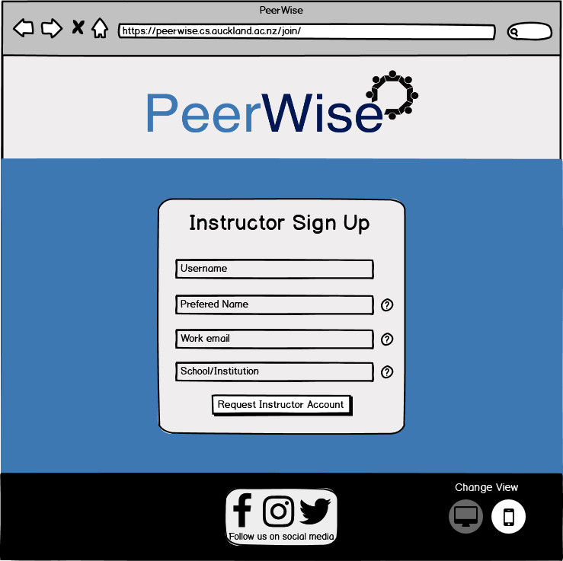

This is similar to the registration page but this is only relevant to teachers and instructors. This allows teachers to request for an instructor account. This account has special privileges such as creating a course and activating a course for students to join. Similarly to the regular sign up page it has question marks to help users gain more information about the field.

**PeerWise Logged in**

**Hans, Matthew, Sarah, and Ryan (Use-case #3, Use-case #9 , and Use-case #10)**

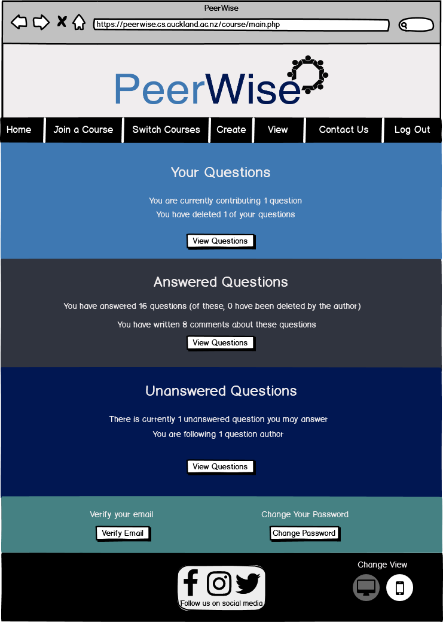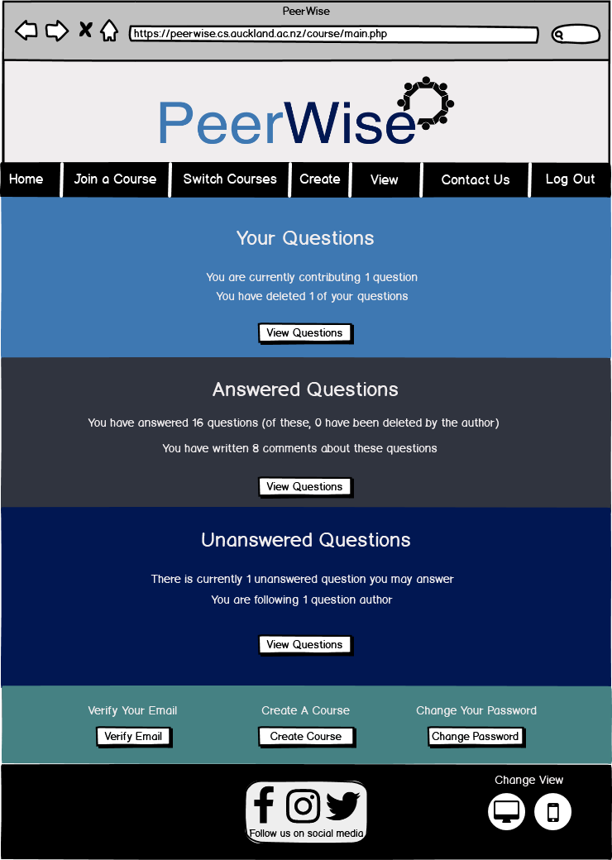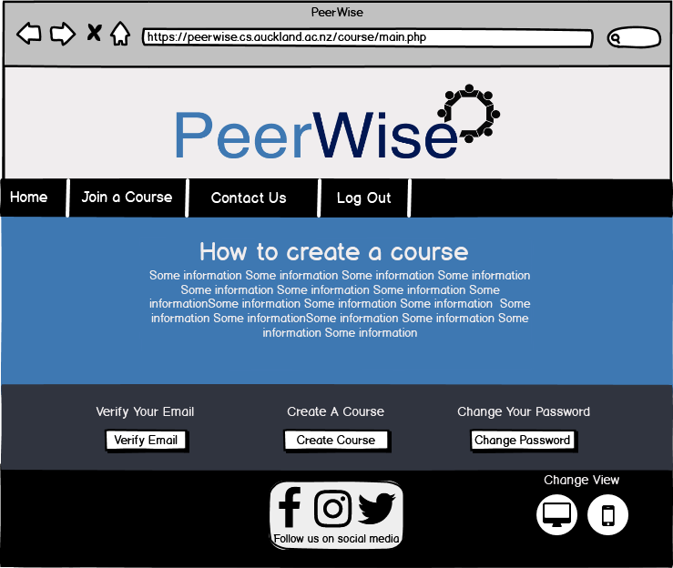

This is the homepage when the user logs into their account. This page now has a navigation bar under the logo then four different sections. Three of the sections are related to questions and the fourth section is for verifying the user’s email and changing their password. The three question sections are about the user’s created questions, the user’s answered questions and unanswered questions. This page follows the front page’s pattern with having light blue, grey, dark blue then teal below the logo in that order. The three question sections also have a title, some information relating to that section followed by a button that leads to that page. The three sections fulfill both students and teachers' needs to access their questions. The questions sections are also centered instead of left or right aligned because users usually focus at the center of the page.

The instructor has a different page where they have an extra button to create a course for their students to join. If the instructor has not joined a course then they will be present with a different page without the question sections and showing only information on how to create a course. This is because if they have not joined a course they would not have any of the necessary questions to fill in the sections, so if they press the buttons to go to the answered questions page for example, it would only show an empty page. This page also has an altered navigation bar since the user is not in a course they get limited access.

**PeerWise Answer Question**

**Hans and Ryan (Use-case #2)**

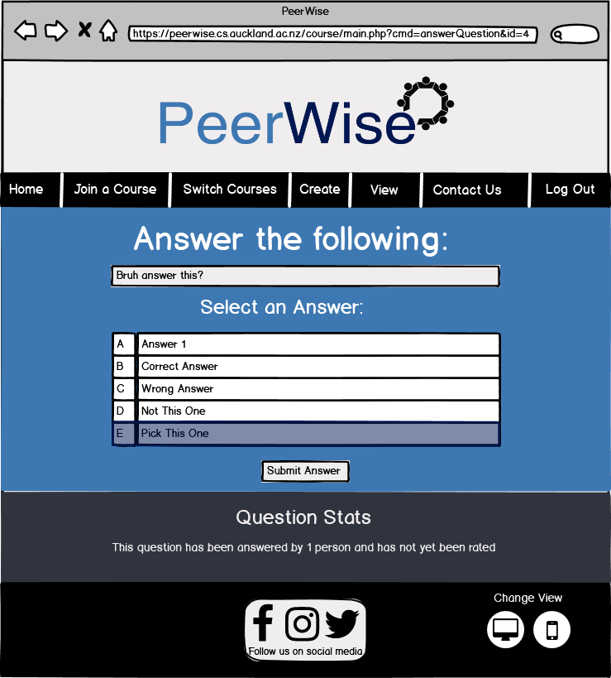

This one of the core pages of the web service. This page still follows the pattern of light blue then grey for the relevant sections so that it keeps the entire website consistent. This page shows an instruction as the title followed by the question and the choices in the center of the page. This is center aligned because we want the user to have their whole focus on the purpose of the page. Then below that will show some statistics of the question if they are interested in that. White text is used to show contrast to the cool blue and grey colours. Black text is used to show contrast to the white colours.

This page also highlights the user’s chosen answer in dark blue. This way the user can have an idea of what choice they picked. We change the highlight from green to dark blue because user’s may assume that they chose the correct answer. This is because green invokes a positive reaction and due to this; users may not think about changing their answer. This has an inverse effect to the colour red where it invokes a negative reaction. Before they go to the results page they need to press the submit answer button. This gives the user a way to choose a different answer if they did not like their previous choice. This page can be used for both students and teachers but will be more relevant to students as they are more likely to ask and answer questions.

**PeerWise Rating Question**

**Hans and Ryan (Use-case #2)**

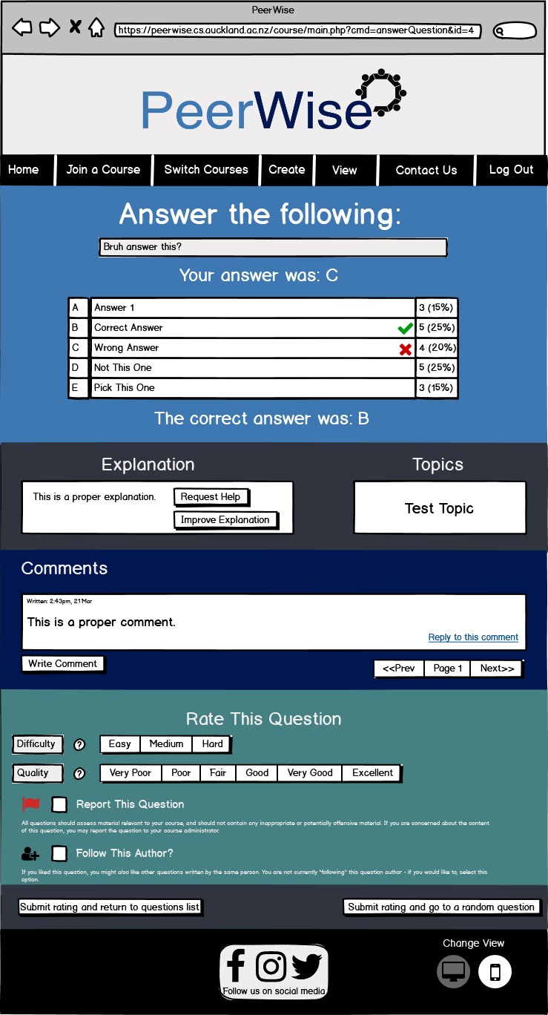

This is the rating questions page which will display after the answer question page when the user has answered a question. Just like the pages before white text on top of dark colours and black text on white colours. This page shows the result of the user's answer which indicates the correct answer with a green check mark and they would see a red cross if they chose the wrong answer. If the user chose correctly then they would only see the green check mark. There are percentages shown to the right of the choices which indicate what percentage were each answer chosen. Below the result section is the explanation of the answer and topics related to the question. In the explanations box contains a button to improve the explanation and one to request help.

Below that section has the comments section where both students and teachers can comment to the question or reply to each other. This section allows teachers to communicate with students and vice versa. There is also a page function in the comments section so when there is an overflow of comments they are pushed to the next page instead of deleted.

The rate section below the comment section contains a rating system that users utilize to give other users how difficult the question is and the quality of the question. They might also choose to report the question and/or follow the author of the question. If users choose to report a question, then the course creator will be notified and act accordingly by either choosing to delete the question or notify the author of the question. If the user chooses to follow the author then they would be shown their followed author’s questions. The report this question and follow this author buttons have information below them that will assist the user of what the following checkboxes do. Finally there are two buttons located below the rate section that indicate to the user to proceed to the next question or go back to the questions list.

**PeerWise Quiz Results**

**Hans and Ryan (Use-case #8)**

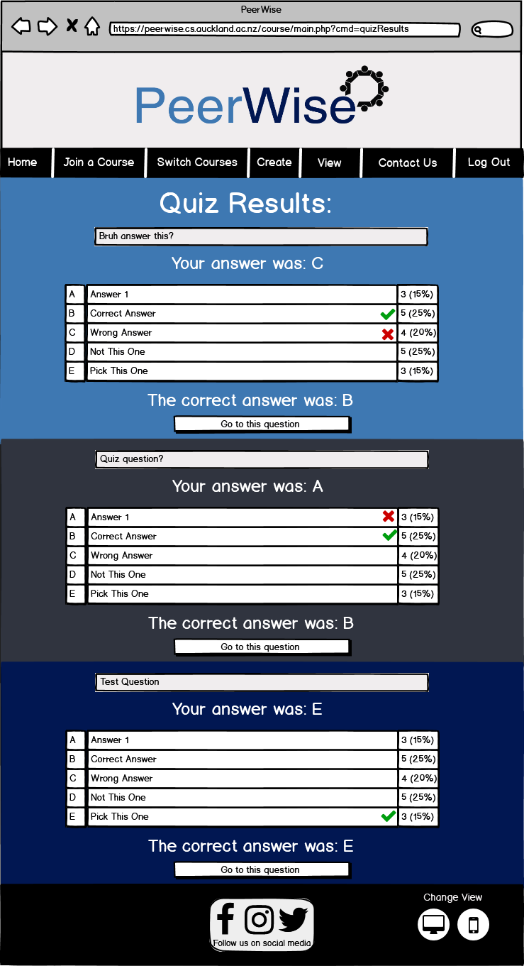

After a quiz has been completed then it will display the results of all the questions. Users are given a red cross mark to indicate that their choice was wrong and a green check mark if for the correct answer. If the user got the question correct then they will not see a red cross mark. Text is also provided on the screen if the user would rather read the results. Below each result of the question has a button to go to the results page of that particular question.

**PeerWise Verify Email, Enter Code and Change Password**

**Hans, Matthew, and Ryan (Use-case #9)**

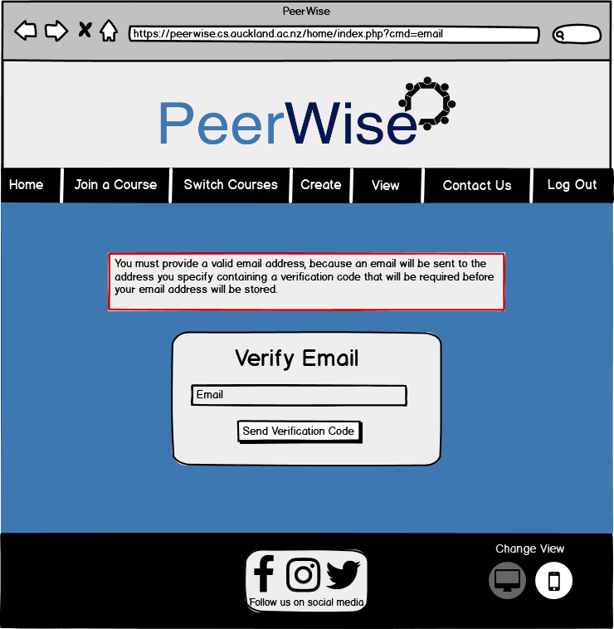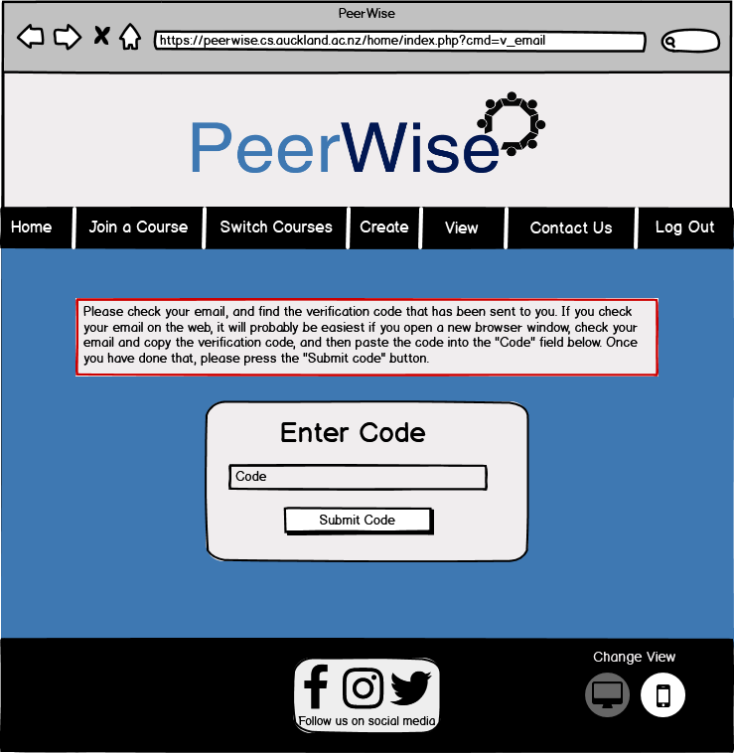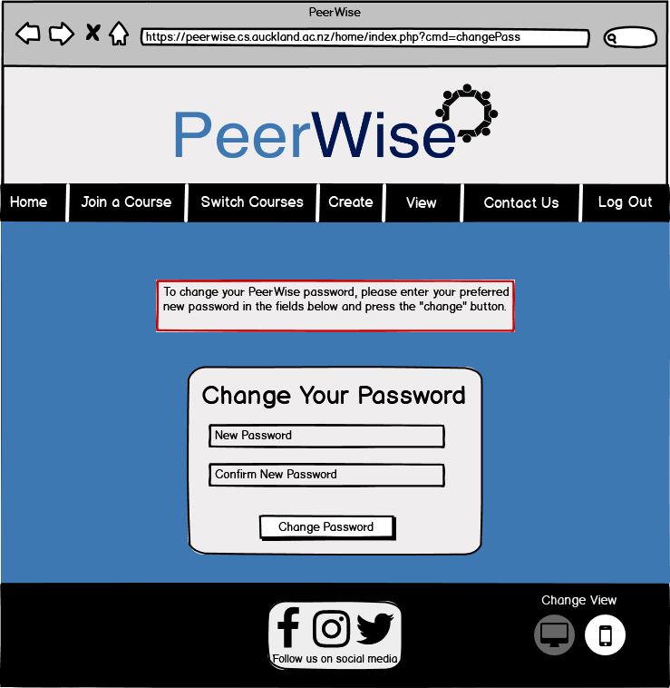

These pages are for users to verify and change their password. A text box is shown to give the user some more information about what to enter in the fields. The verify page would only be used once by a user since they only need to verify their emails once. Also users don’t often change their passwords since it would only confuse them more if they have multiple accounts with different passwords. We added these if the user has a security breach and they had to change their passwords. Change password also has a confirmation and it will only allow the user to change their password if both fields are identical. This allows the user to make sure that their password is what they want it to be and they didn’t make a mistake during the input. If we did not have the confirmation and they entered their password with a mistake this would create trouble when they inevitably have to log in and find out that they typed their password wrong.

**PeerWise Join Course and Activate Course**

**Matthew, and Sarah (Use-case #3)**

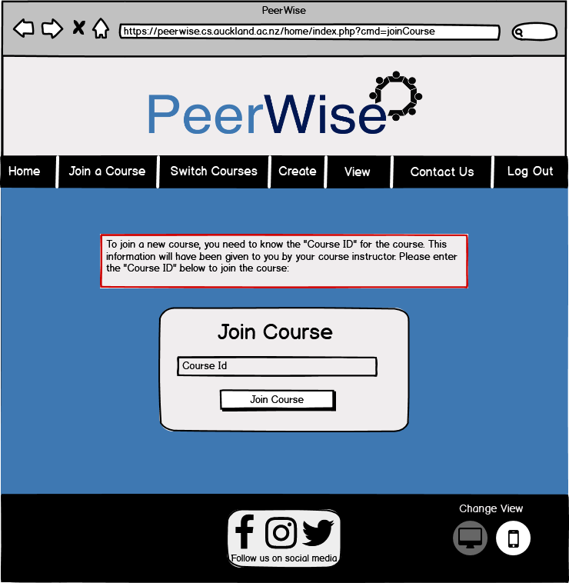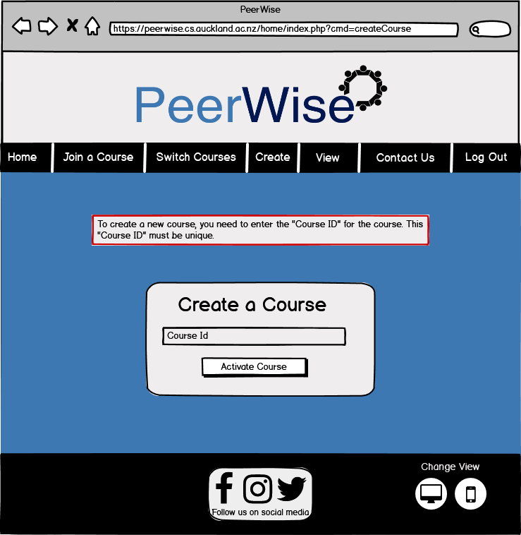

These pages look similar to the others to keep consistency. They contain a box below the navigation bar which gives information to the user about what to enter in the fields. Join course is accessible through the navigation bar below the PeerWise logo and both students and teachers can use this, while the create course is only available to teachers. This fulfills the needs of students by being able to quickly join a course and immediately participating by creating questions and/or answering them. Creating a course allows teachers to separate their classes if they teach multiple classes. This way different courses with different course outlines don’t overlap in the same environment. If we had every course created by that teacher be grouped together then the questions that students will make will be focusing on a variety of topics instead of having a specified topic like software design.

**PeerWise Forgot Password and Reset Password**

**Hans (Use-case #10)**

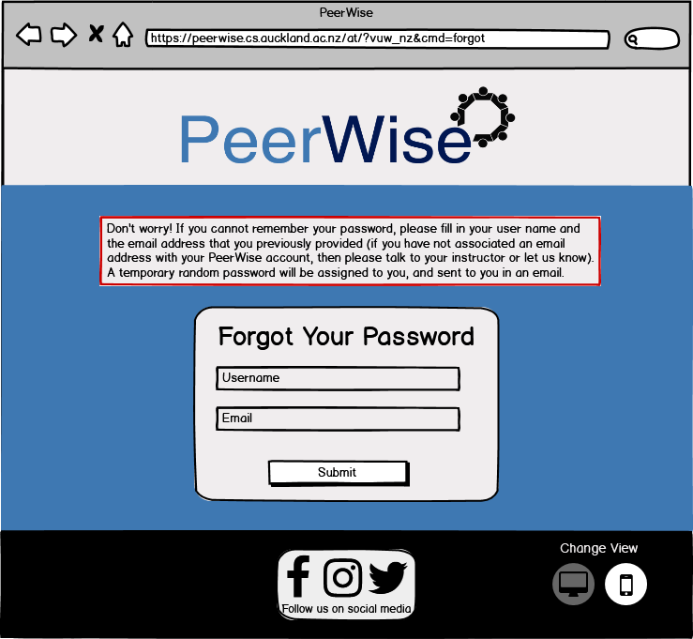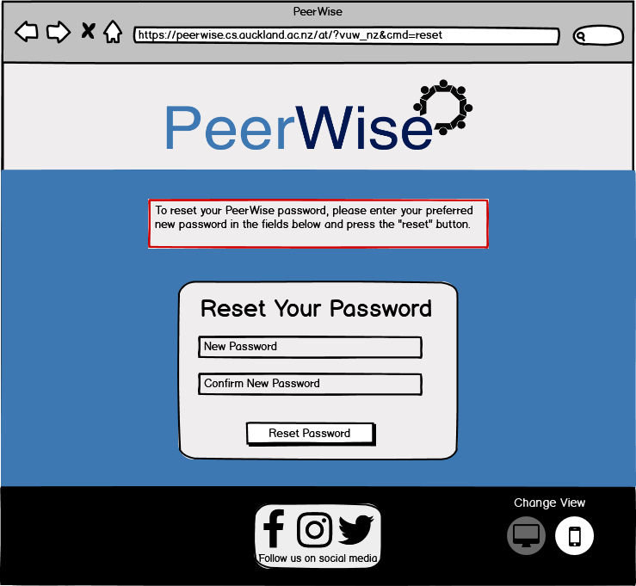

These are different to the change password page as changing the password needed the user to be logged in. These pages are necessary for users that might forget their password. This could be busy students or teachers or even forgetful students or teachers. Whatever the reason may be users will forget their password at some point so having a way to reset it is essential to the success and longevity of a website. We want users to authorise and authenticate themselves before letting them reset their passwords so a link will be sent to their emails and if they have requested to reset their password if they did not they can ignore that email. It is the system's responsibility to be able to use a third party to confirm the user's identity otherwise another user can change the password of a different user.

**PeerWise Badges/LeaderBoards**

**Matthew, Sarah, and Ryan (Use-case #14 and Use-case #15)**

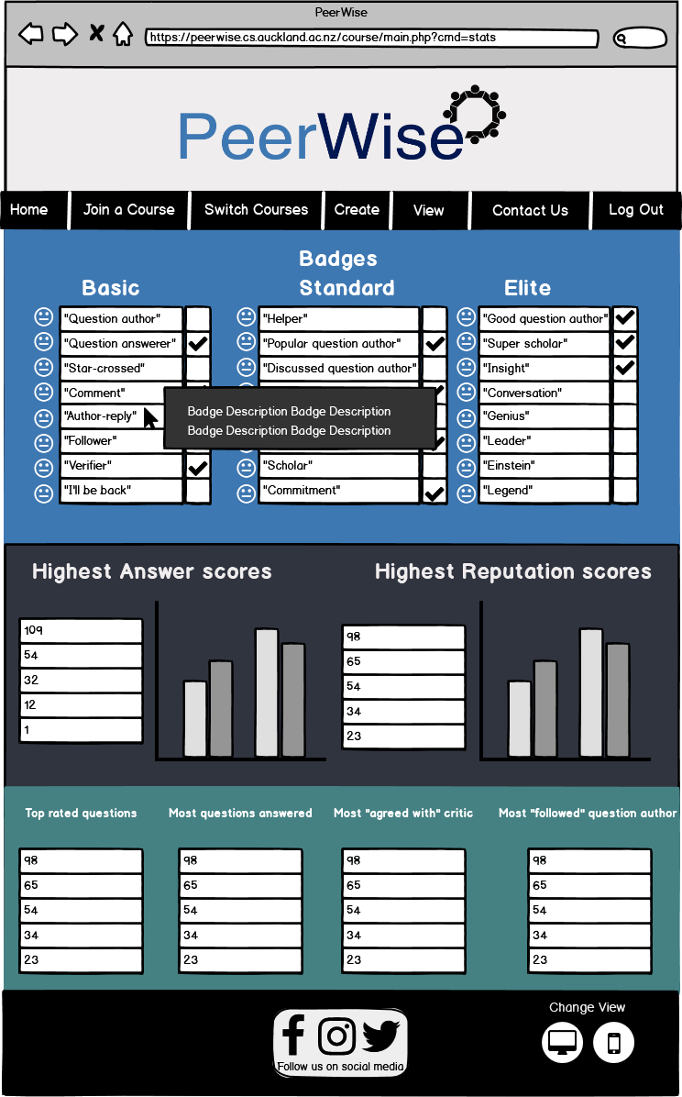

We decide to combine badges and leaderboards into one page as they have similar functions and that is to present the user’s achievements and statistics. This page is a bit more different to the other pages in the website as it mainly shows graphs and tables. There are placeholders icons to represent the badges and when hovering over the box it shows a pop up of the badge description. The tables show the score of the top 5 users and represent the answer and reputation scores on a graph.

We also wanted to keep consistency but since this is such a different page we made the choice to break the pattern at the bottom section as we decided that having the teal colour would be more appropriate to represent the tables. We wanted to have two light colours then a dark colour between the two. If we had the dark blue next to the dark grey next to each other, then it wouldn’t give as big of a contrast to split the two sections in comparison to a dark grey to a teal colour.

This fulfills the needs of teachers that want to see that are interested in wanting to know the statistics of their course. They can use this information to improve their lectures. Students can also make use of this page if they want to compete with other students. This will increase participation in the course as a whole and will therefore increase their learning.

**PeerWise Quiz Creation**

**Hans, and Ryan (Use-case #8)**

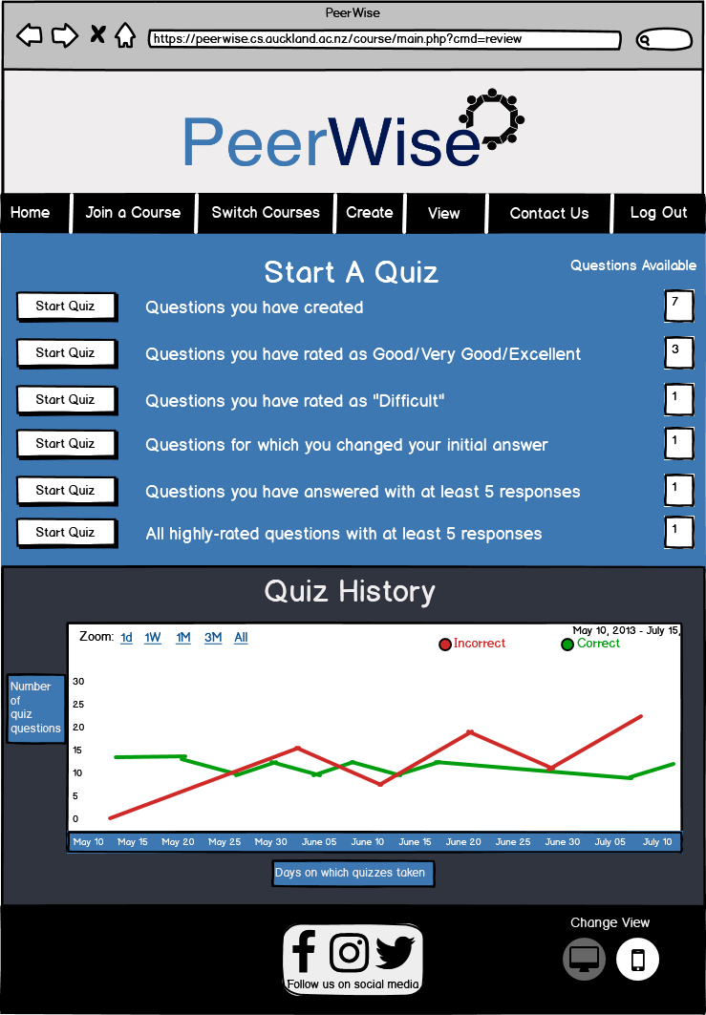

This is the quiz page, where users can start a quiz based on different aspects. This will display all the questions related to that aspect. Users cannot start a quiz if there are no questions available. Below the quiz section has the quiz history which displays the user's correct and incorrect answers on a line graph. Green is used to represent the correct answer and red to represent the incorrect answers. These colours were chosen because they invoke positive and negative emotions respectively.

**PeerWise Feedback page**

**Matthew, and Sarah (Use-case #13)**

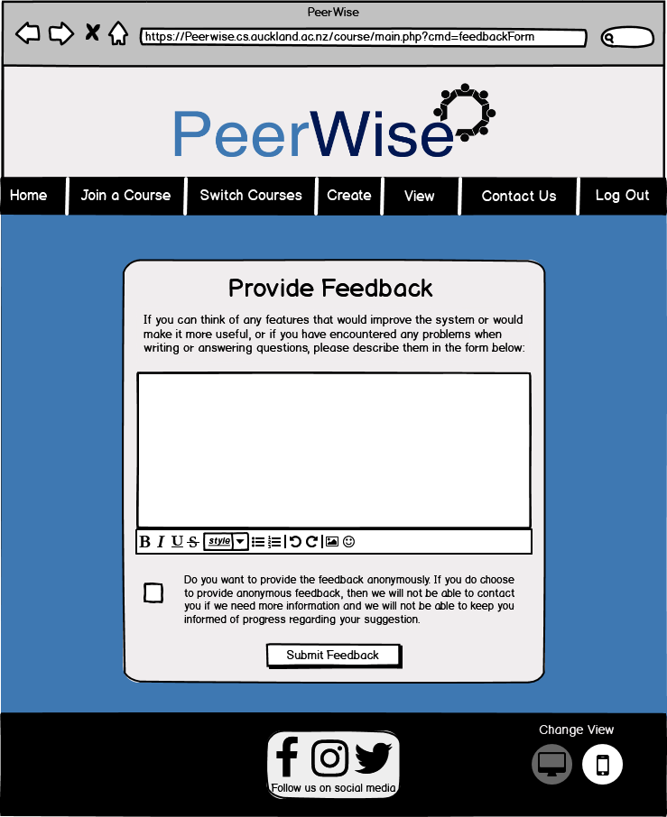

This page is accessible to all users that wish to provide feedback to PeerWise. They can enter their feedback in the white text box and edit it using the tools located below. They can click the box that allows them to send feedback anonymously if they don’t want to be known. If users do this PeerWise will not know who to respond to if they have further inquiries about your feedback. It is part of the system's responsibility to give users the right to remain anonymous if they want to be. This is necessary for users that want to send feedback to help improve PeerWise.

**View All Your Questions**

**Hans and Ryan (Use-case #11)**

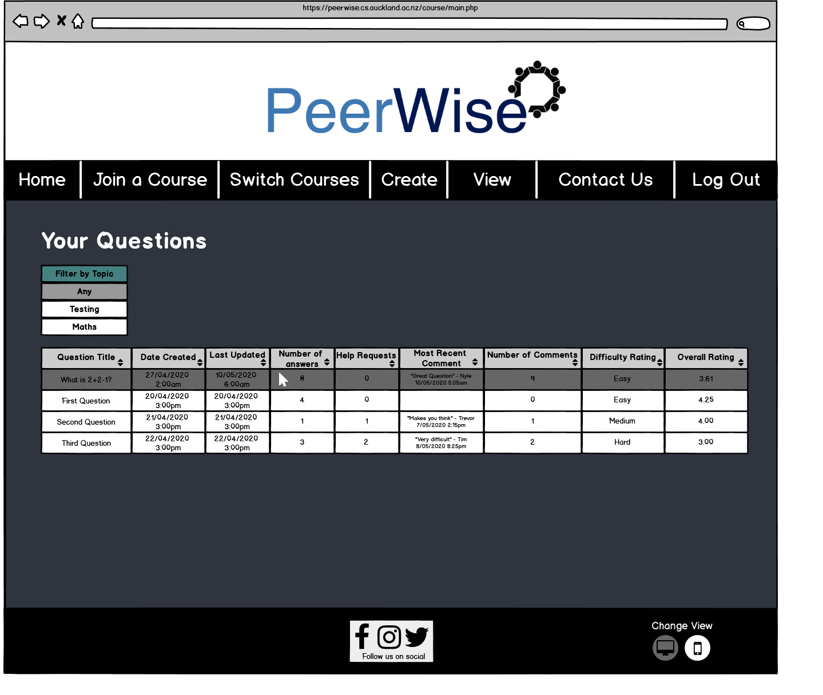

This page is to show the user all their questions in a convenient and compact way. In regards to the body of this page like in PeerWise original design I stored the users questions in a table with the table columns being mostly the same (removed ‘your answer popular’ column as it was unnecessary). To provide more information to the user I changed the most recent comment column to show the contents of the comment and the date rather than just the date. When the user hovers over a row it darkens so the user can easily see what row they are on. If they click on the row it will take them to the ‘Viewing your question’ page which shows details of the question. PeerWises’ old design had this functionality in a separate column called “Click to View” however, this design integrates the functionality into the table itself, providing a cleaner interface. This page along with the ‘View All Answered Questions’ page and the ‘View all Unanswered Questions’ page have an option to filter questions by topic. Currently the filter is set to ‘Any’ meaning questions with any topic are shown. If one of the other topics are clicked on then the table will only show questions that have that topic. This filtering function allows users to narrow down the questions they are looking for, it is especially useful when they are a part of a big PeerWise course with lots of questions. Hans and Ryan are the main two personas that would visit this page as Matt and Sarah aren’t very likely to create questions, they are more likely to be monitoring students' questions.

**View All Answered Questions  
Hans and Ryan (Use-case #11)**

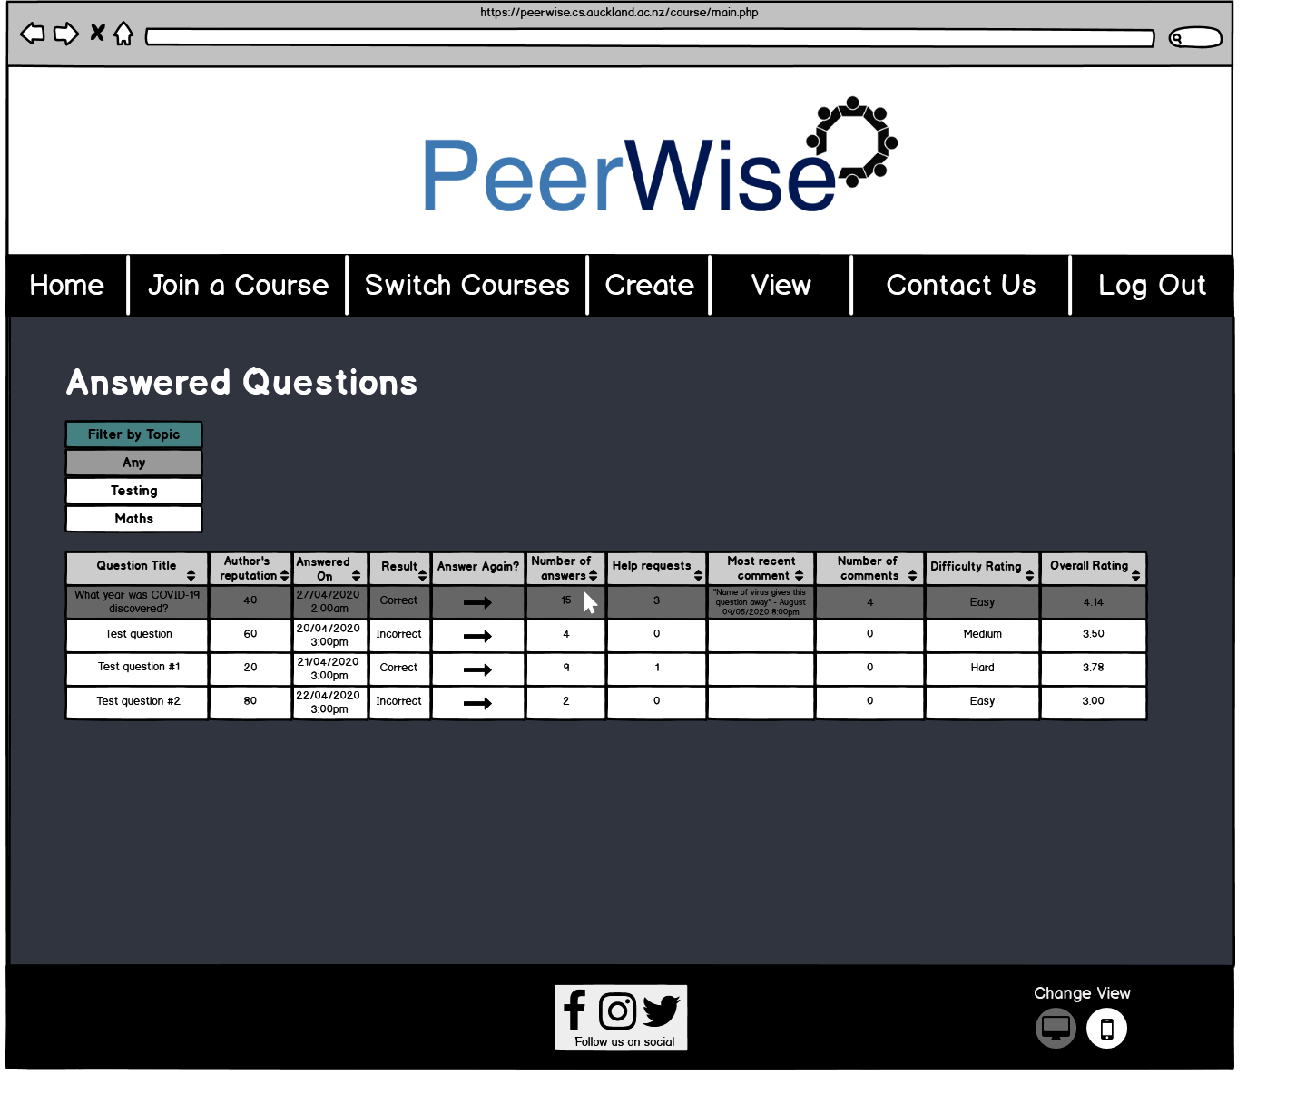

This page shows the user all their answers to questions created by other users. In this page I kept the same dark grey background, white table and white headings as the page ‘View All Your Questions’ and ‘View all unanswered questions’. This is because the purpose of these three pages are similar and have a similar format of content therefore it makes sense that the colour scheme/layout of these pages are consistent. When a user clicks on the row of this table it takes them to the details of their answer (‘View your answer to a question’ page). If the user clicks on the column ‘Answer again’ for one of the answer rows then it will take them to the page when the user can answer the question again (‘PeerWise Answer Question’ page). Though it is not ideal to have a column contain a link in this way, the row itself is already linked to the ‘View your answer to a question’ page therefore, this was the best way of including this functionality. Hans and Ryan would be the only two personas that would likely use this page as teachers won’t be answering questions since they do not need to learn course/subject content as they are the ones who teach it.

**View all unanswered questions**

**Hans, Ryan, Sarah and Matthew (Use-case #11)**

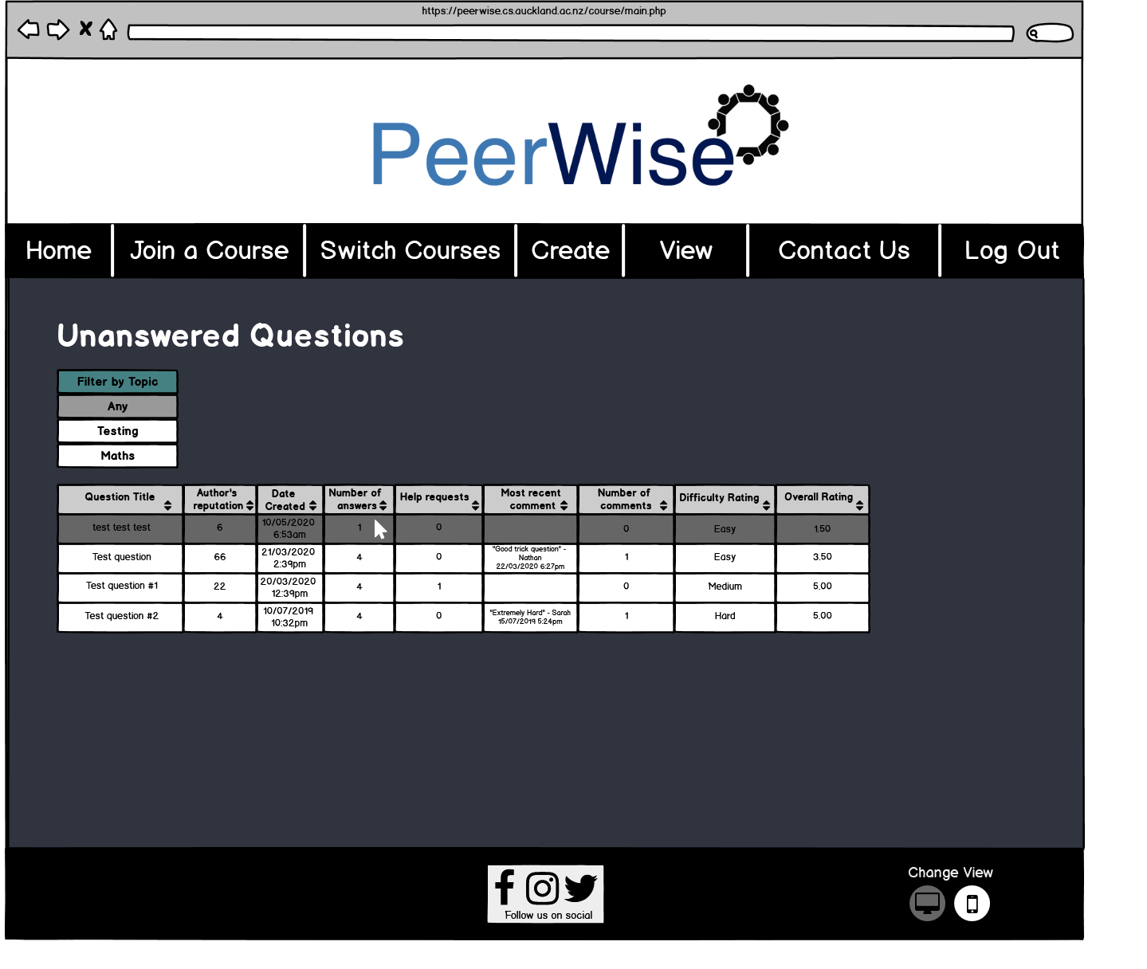

This page is showing unanswered questions from any user. Like the two pages discussed above the table can be sorted (ascending/descending) depending on the columns content by pressing the small up/down arrow in the column header. E.g. Question Title is sorted alphabetically whereas Author’s reputation is sorted numerically. Most recent comment is sorted by date rather than alphabetically. Clicking on a row in the table takes the user to a page where they can answer the question (‘PeerWise Answer Question’ page). Storing this information in a table means it's easy for the user to identify different parts of the information and as mentioned just before, allows them to sort the information. All personas will use this page, Hans and Ryan so they can answer questions and learn course/subject content and Matthew and Sarah so they can see what kinds of questions students are submitting.

**Viewing your answer to a question**

**Hans and Ryan**

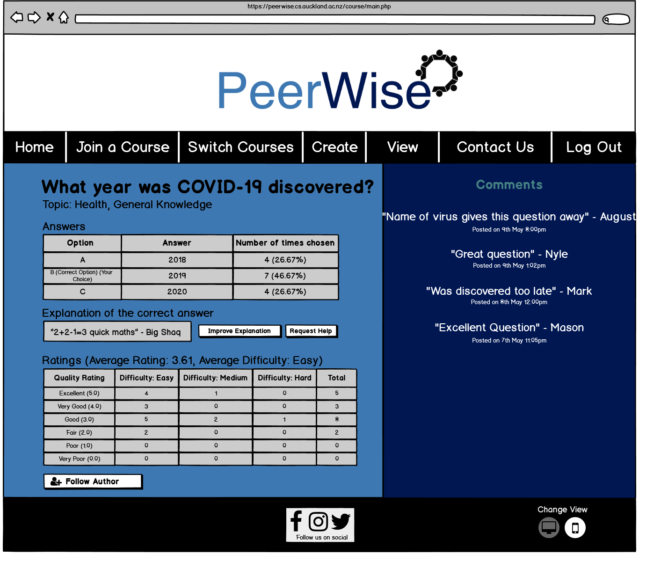

This page shows the details of an answer the user has made in the past. Only Hans and Ryan would visit this page as students will be the only ones answering questions on the website. This page uses a lot of different colours to make the page exciting. The main changes (non-aesthetic changes) between this design and PeerWises’ old design is PeerWises’ answer table was very confusing (see photo below) as a user likely won’t know what ‘First Answers’ and ‘Confirmed Answers’ mean. So, the table only now shows the number of times an answer is chosen.

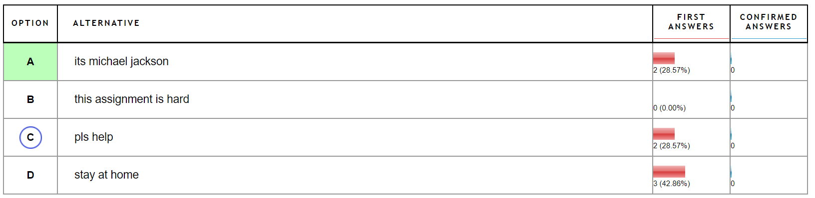

I also changed comments to not be anonymous to prevent ‘internet trolls’ abusing PeerWises’ comment system. The comments section is a scroll feed so if the comments exceed the length of the section, then a scroll bar will appear. This means the user can see all the comments by using the scroll bar.

**Creating questions**

**Hans and Ryan (Use-case #1)**

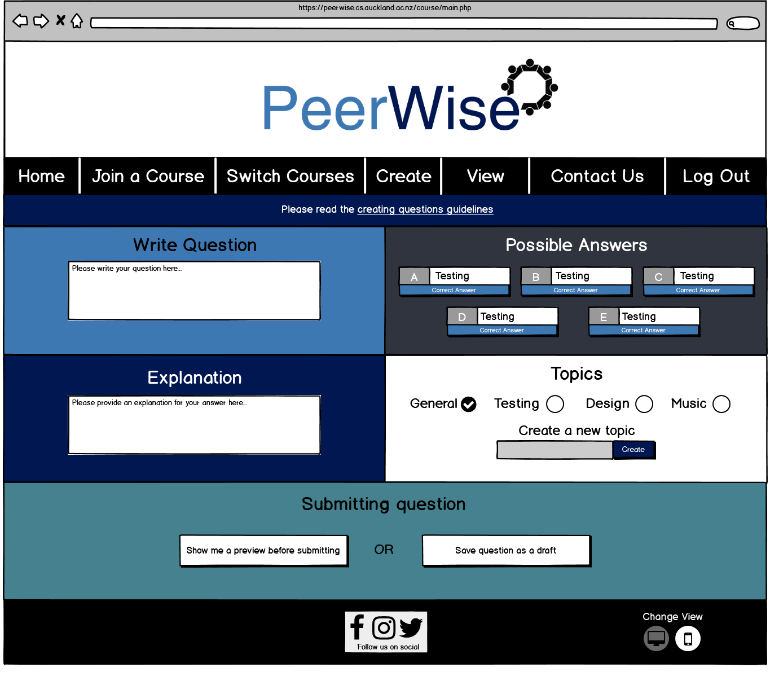

This is the page for creating questions, one of the most important functions of PeerWise. This page follows the colour scheme of PeerWise (shades of blue, cyan, grey, black and white). PeerWises’ old design requires a lot of scrolling and has multiple paragraphs explaining what each section means. This is messy and overloads the user with information. So, the new design doesn’t require scrolling and the information which can help the user create good questions have been moved to a seperate window called ‘creating questions guidelines’. A link to this window is included below the taskbar. This design has the same sections as the old design as we did not feel it was necessary to change how creating a question is done. A question can still be assigned multiple topics by checking multiple circles in the ‘Topics’ section. Saving the question as a draft will do so and take the user to the page where they can see all their created questions. If the user wants to edit and publish their draft in the future then they can do so by accessing the page via the navigation bar.

**Guidelines window**

**Hans and Ryan (Use-case #1)  
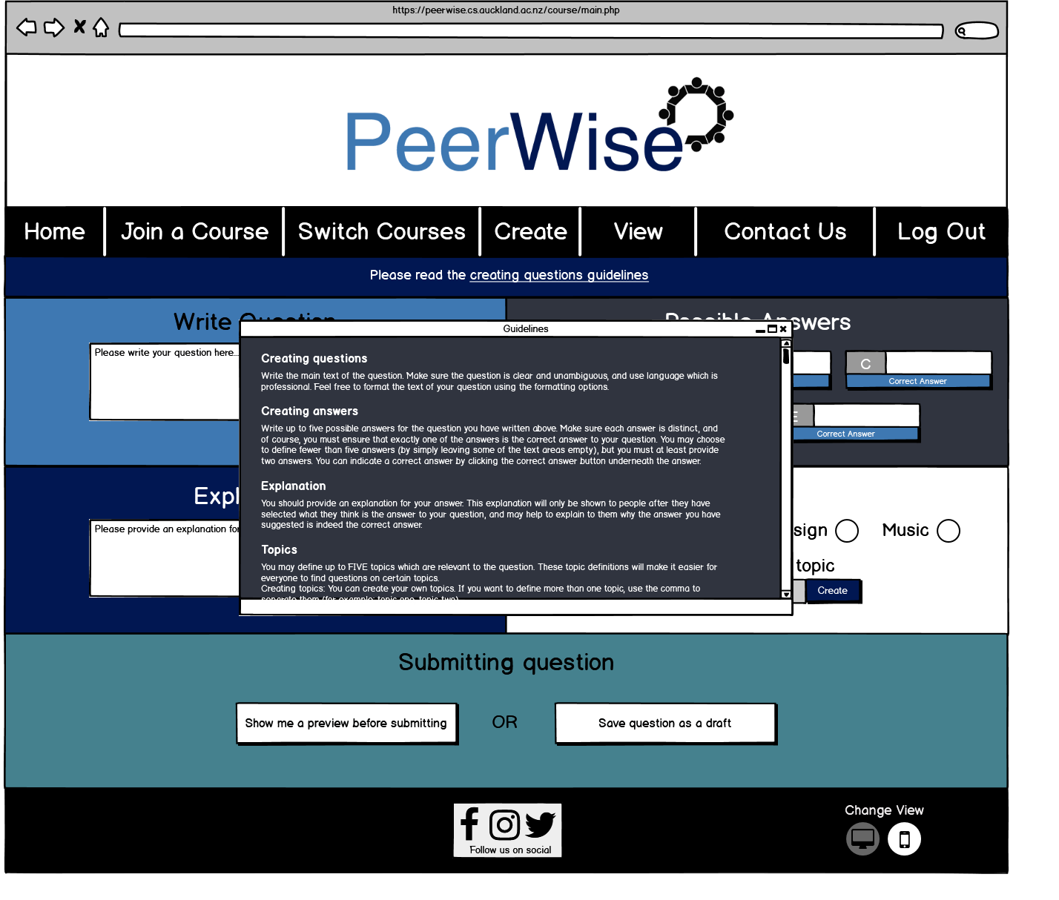**

This page is just showing what the ‘creating questions guidelines’ window looks like. It is a pop-up window meaning the user can close or minimise it at any time and resume creating their question. The guidelines have a scroll bar so the window doesn’t have to be big or the text doesn’t have to be small to fit the text in the window.

**Preview Question**

**Hans and Ryan (Use-case #1)**

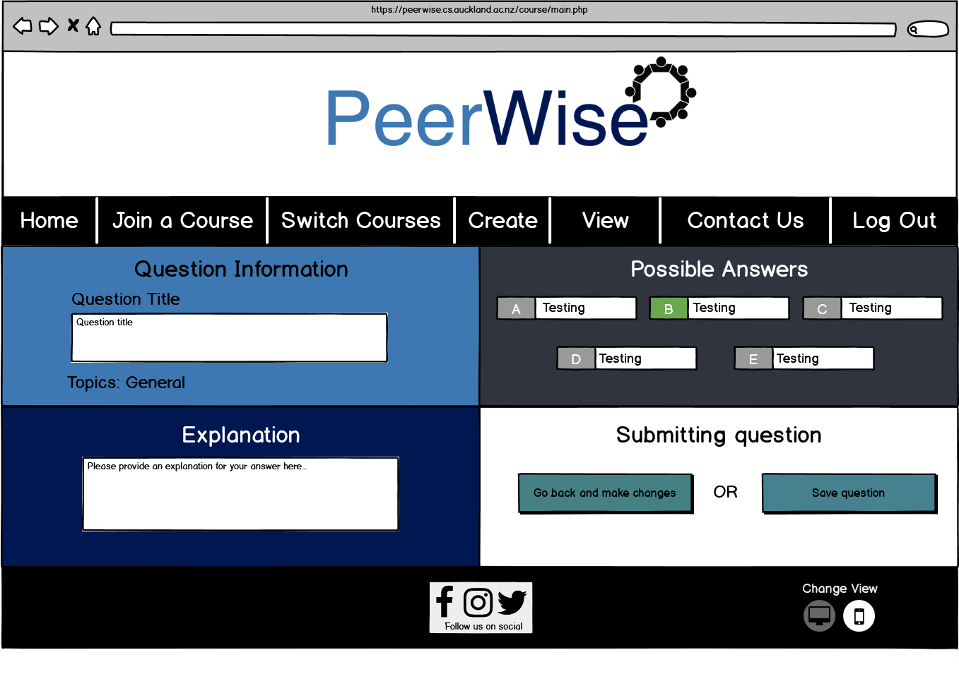

This page has a very similar design to the creating questions page since they are directly related. This page is only accessed if the ‘Show me a preview before submitting’ button is pressed on the creating questions page. This page previews all the fields of the question and it allows the user to go back to edit their question by clicking on the ‘Go back and make changes’ button or they can publish the question by clicking on the ‘Save question’ button (the user will be taken to the page showing all their questions after). Under the ‘Possible Answers’ section the correct answer is indicated by a green background on the answer letter (e.g. B in the photo above).

**Viewing your question**

**Hans and Ryan**

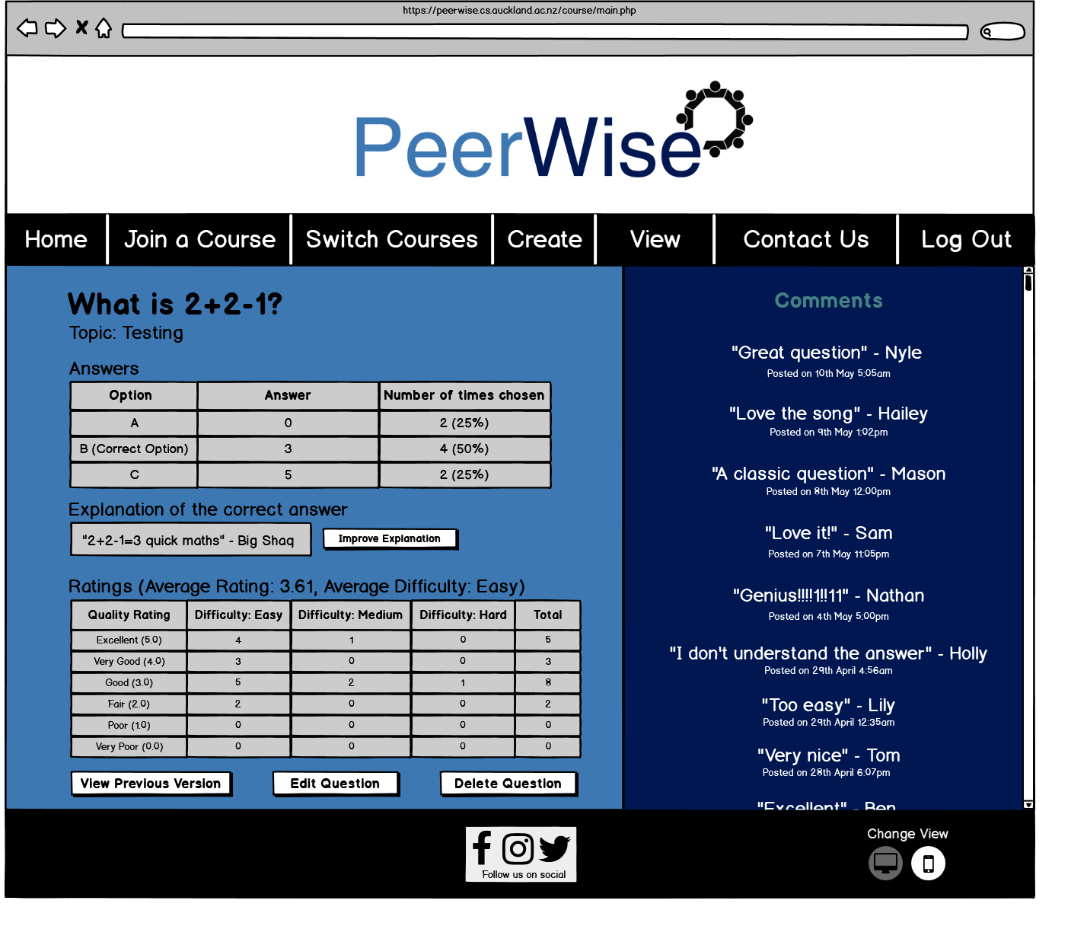

This page shows the details of a question the user has created. The user can improve the explanation by clicking on the ‘Improve Explanation’ button. The purpose of this is in case the explanation of their question is lacking, though the user can also edit their explanation (and the rest of their question) by using the Edit Question button. If the question has previous version (versions before editing) the user can view the most recent previous version using the ‘View Previous Version’ button. They can also choose to delete the question. This page mimics the layout of ‘Viewing your answer to a question’ page as they both are similar (viewing the details of a question/answer).

**Improve Explanation**

**Hans and Ryan**

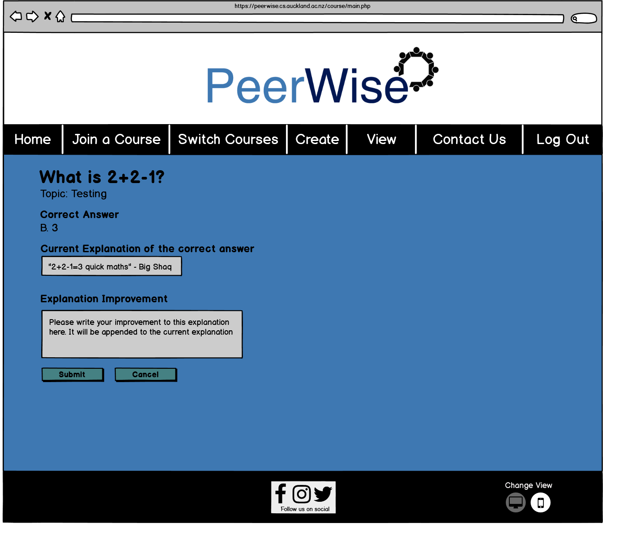This page lets the user improve the explanation of any question (their own or others). They can only improve the explanation of a question they didn’t create if they have answered the question. The design of this page is less complicated than the designs of the pages above (doesn’t have multiple sections etc.) as the task it is doing is less complex. The first text box on the page can’t be edited by the user but the second can. The text in the second text box is appended to the first once the user clicks the Submit button. If the user clicks the submit button or the cancel button then they are taken back to the page they used to reach this page.

Sarah and Matthew won’t be visiting this page as they won’t be creating or answering questions however, an improvement on our new design for PeerWise would be if instructors could improve explanations to questions without having to answer them. This would allow teachers to help students understand questions by improving weak explanations.

**Previous Versions**

**Hans and Ryan**

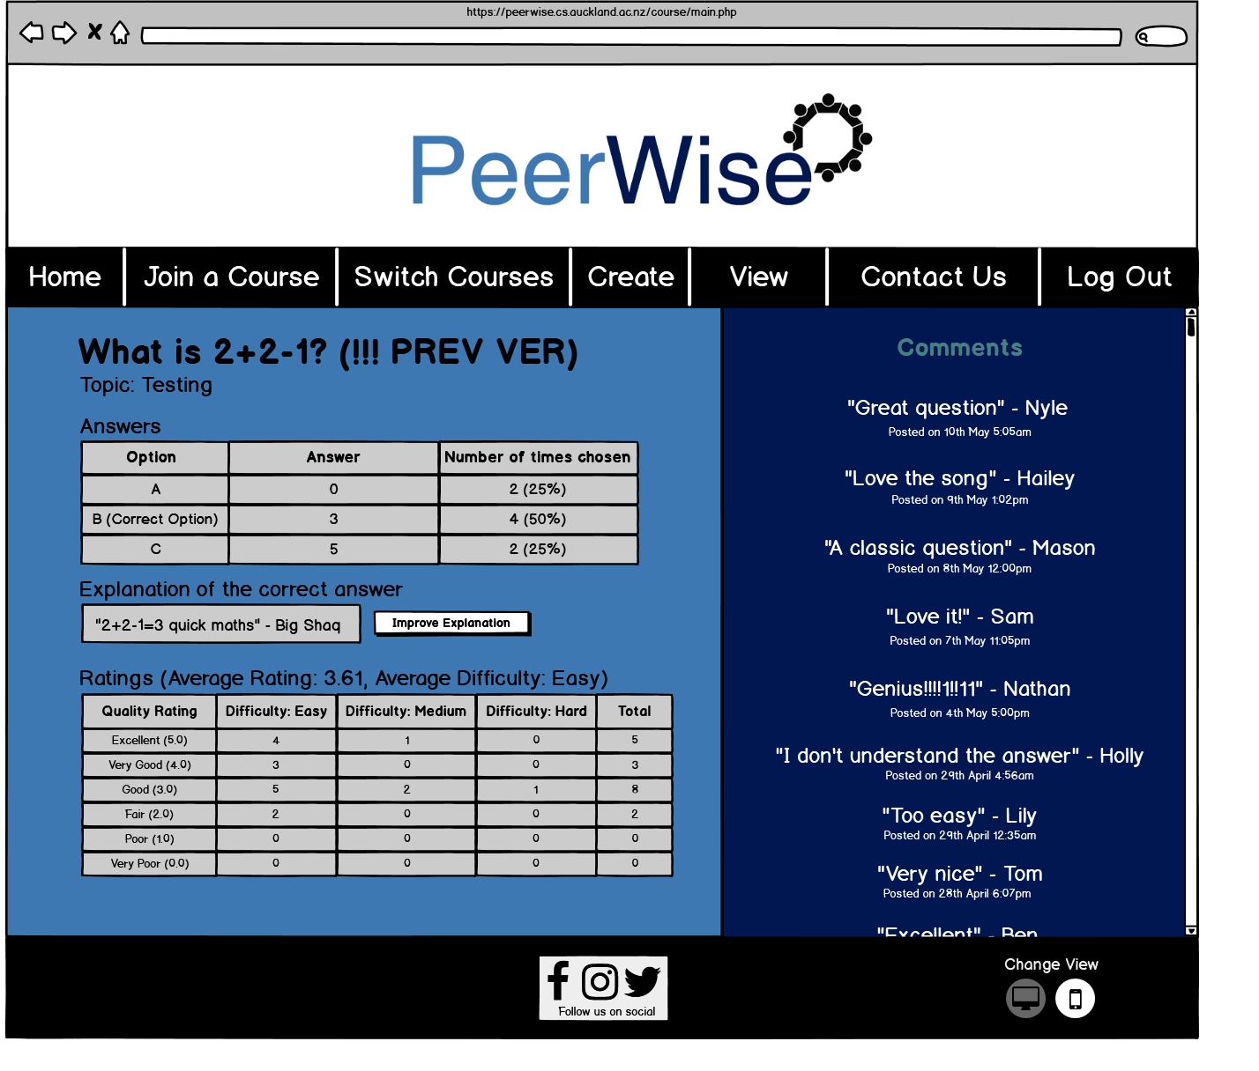

This page shows the previous version of a question. E.g. The difference between this version of the question 2+2-1 and the current version is this version has ‘(!!! PREV VER)’ as part of the title. Since this is a previous, archived version of the question the user can’t edit or delete it however, they can still improve the explanation of it so it is not a static archive. The design of this page is essentially identical as the design of the page showing the current version for consistency’s sake.

**Delete Question Confirmation**

**Hans and Ryan (Use-case #7)**

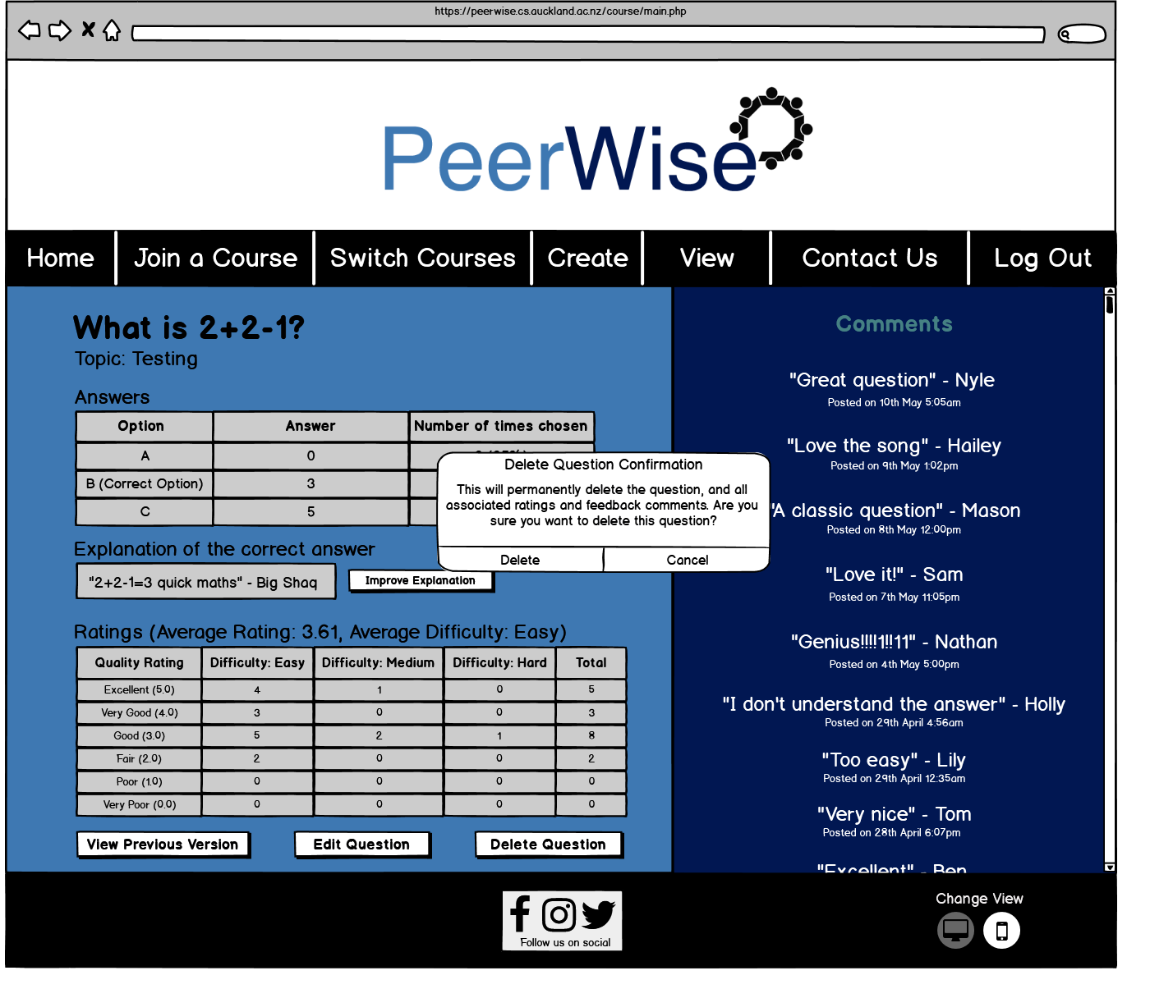

Since Hans and Ryan will be the only personas creating the questions, they will also be the only personas deleting questions as well. This page is exactly the same as ‘viewing your question’ except it has a window making sure the user wants to delete their question. The window can’t be minimised and only closes once the user either chooses to delete the question or not delete it. Making the user confirm deleting their work is used on many websites/systems/services as it is irreversible and it prevents the user misclicking on the button and accidentally deleting their work. If the user clicks on the cancel option the window closes and the question is not deleted. If the user clicks the delete option the question is deleted and the user is taken to the page where they can view all their questions.

**Edit Question Confirmation**

**Hans and Ryan (Use-case #6)**

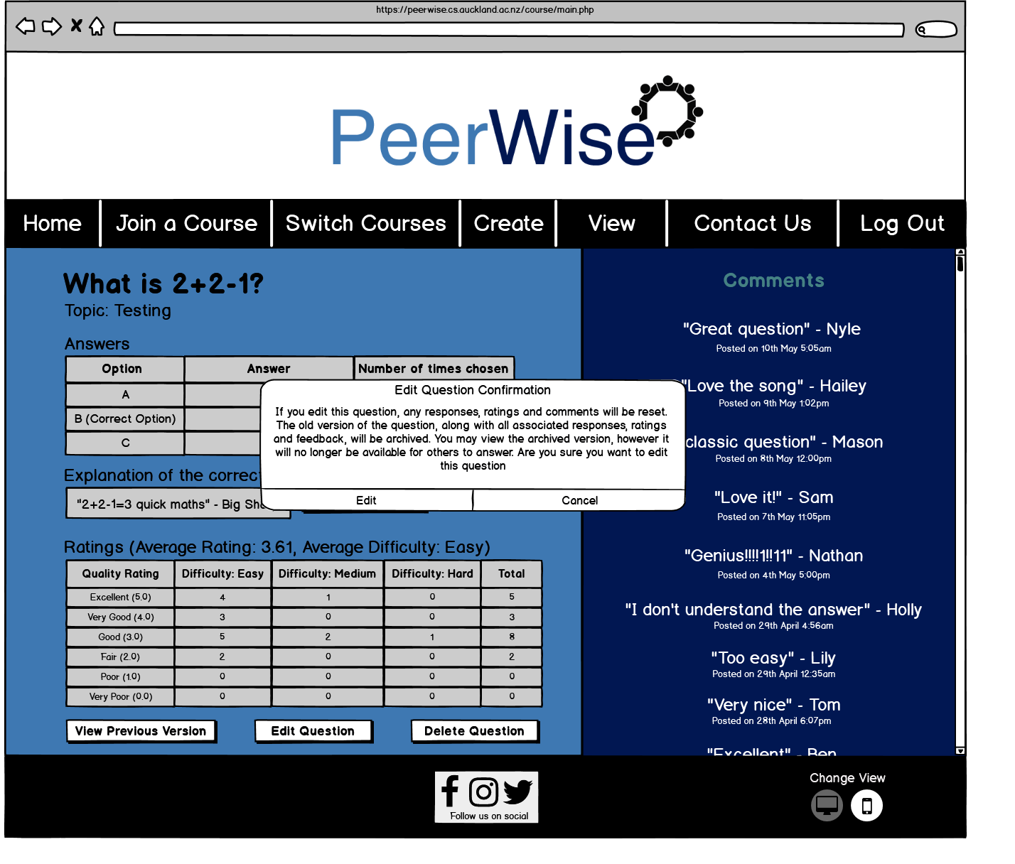

Since Hans and Ryan will be the only personas creating questions they also will be the only personas editing questions since users can only edit their questions, not others. So, they will be the only ones seeing this pop-up window. This page is like the delete question confirmation page in the sense that the only difference between this page and the viewing your question page is the pop-up window. Having this confirmation window is necessary since editing the question will mean any responses, ratings and comments will be archived along with the question itself. This means the question will have no responses, ratings and comments so, it is important that the user knows this before editing their question. Clicking the edit option will take the user to the editing question page whereas clicking on the cancel option will close the window.

**Editing questions**

**Hans and Ryan (Use-case #6)**

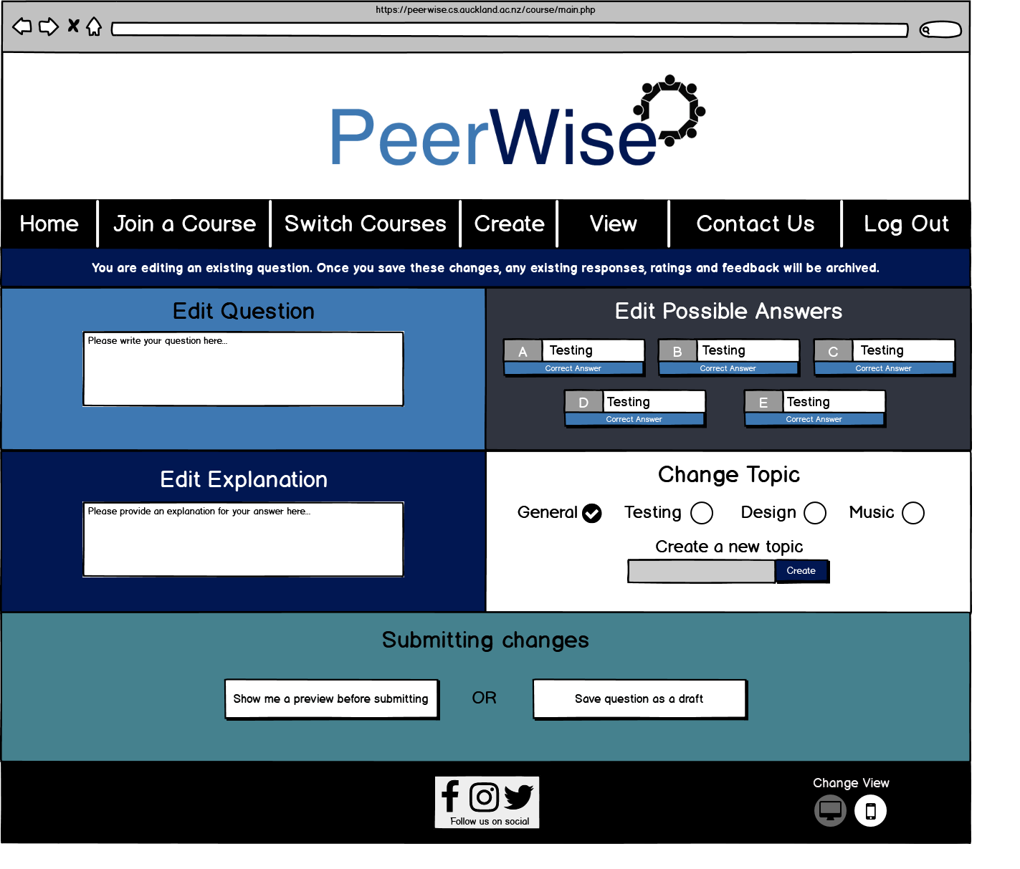

This is the page for editing a question you (the user) have created. It looks essentially the same as creating the question since editing a question is just changing the fields of a question that was initially created. There is a message underneath the navigation bar reminding the user that once they click the ‘Show me a preview before submitting’ button that the questions responses, ratings and comments will be archived and can be seen using the ‘View Previous Version’ button that is on the ‘viewing your question’ page. Saving the question as a draft will store the edited question in a draft but it will not publish these changes.

**Viewing all comments on your questions**

**Hans and Ryan**

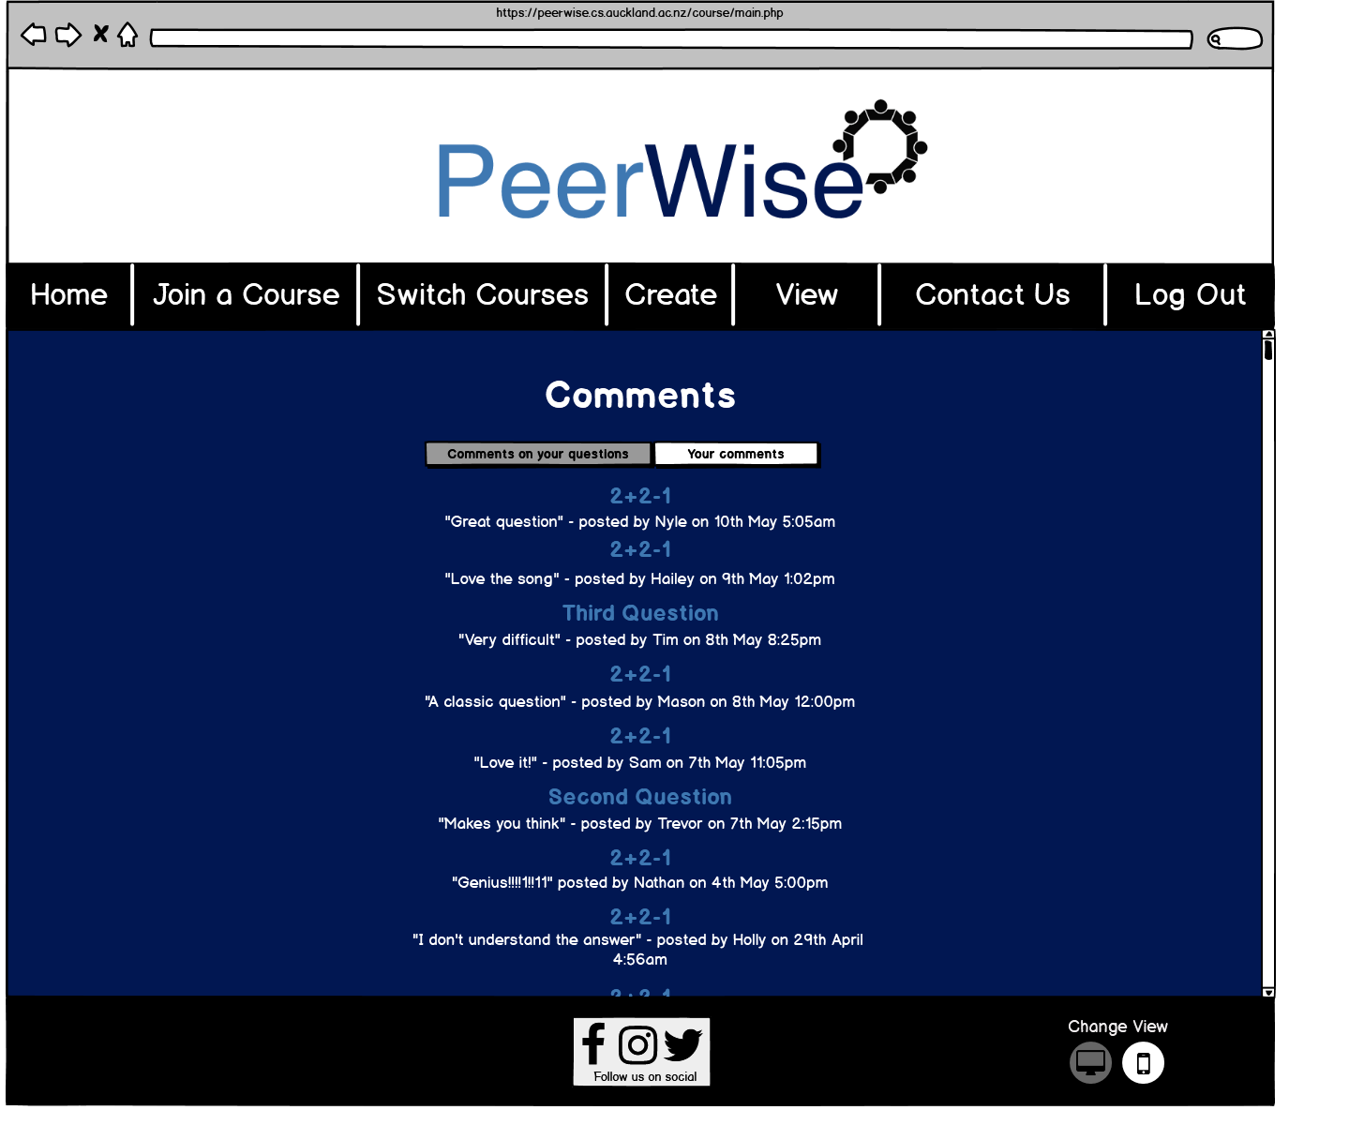

This page lets users view all comments on their questions. This is so that they don’t have to visit each question to see the comments, instead they can just visit this page and see all the comments at once. There are two modes to this page (‘all comments on their questions’ and ‘all the comments they have made’) and the user can switch between these modes using the buttons above the comments. The darker button indicates the current mode. This page has a scrollbar so the user can see all the comments. Users can quickly access the question that the comment was made on by clicking the comment heading. Only Hans and Ryan would visit this page since Matt/Sarah aren’t creating questions.

**Viewing all your comments**

**Hans and Ryan**

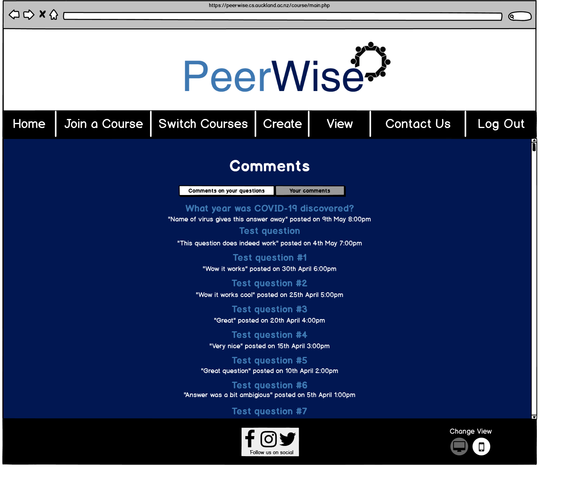

This page is showing the other mode of the viewing comments page. The headings of the comments link to the answer the user made that included said comment. The format of the comments are exactly the same as the other mode (except it doesn’t show who it is from since all the comments are from you) since it doesn’t need to be different. Sarah and Matthew wouldn’t be using this mode either since to make a comment on a question you must first answer the question.

**Navigation Bar Switch Courses Options**

**Hans, Ryan, Sarah and Matthew**

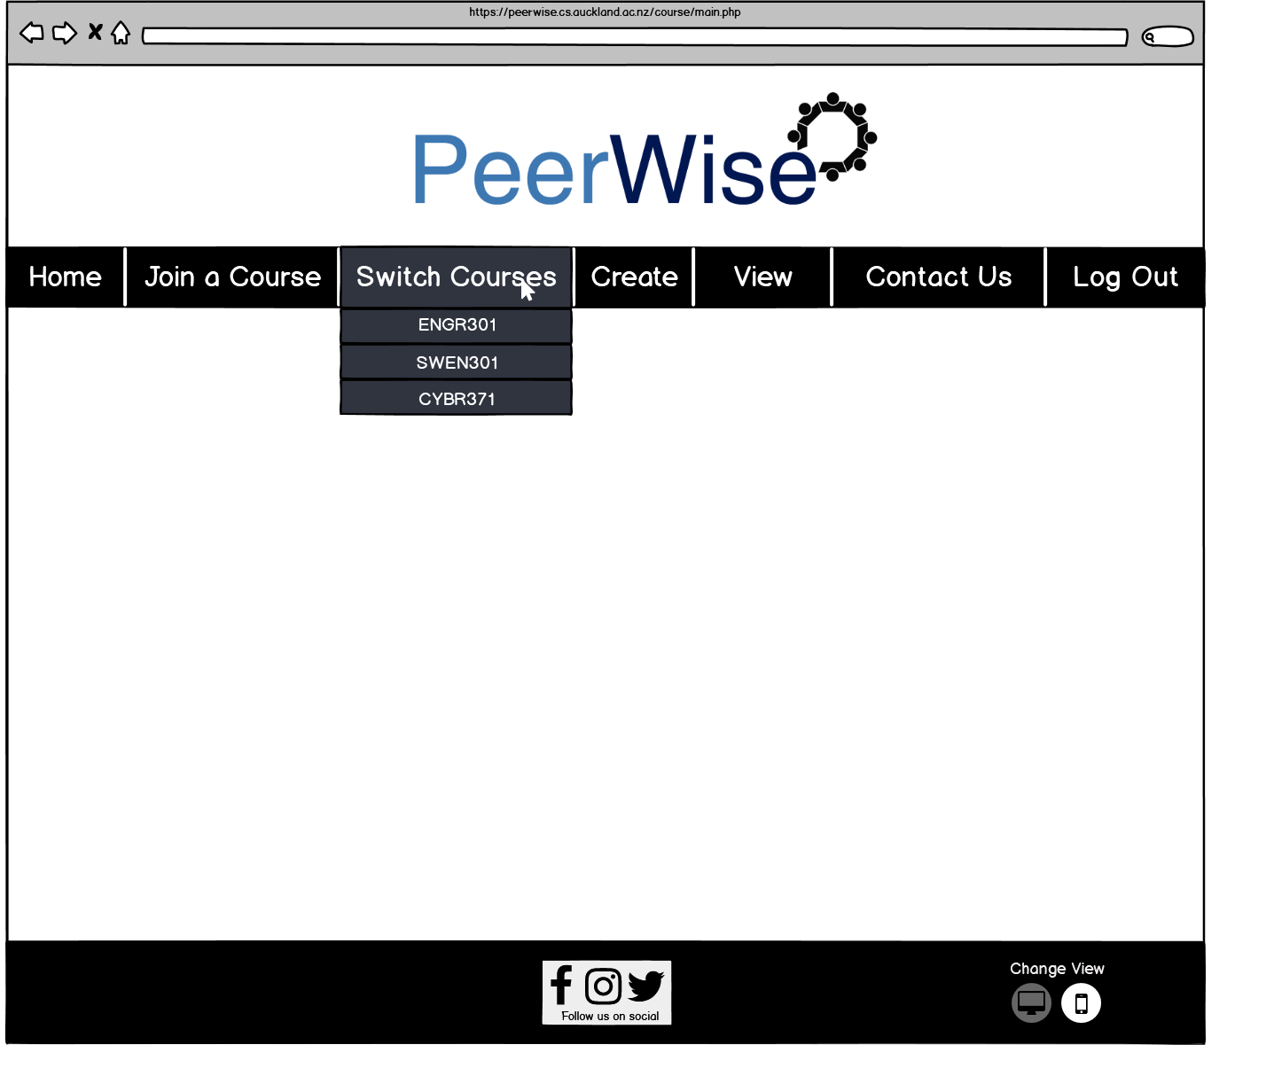

This page shows what options appear when the user hover overs a tab in the navigation bar that has options. There are three tabs in the navigation bar that have options, ‘Switch Courses’, ‘Create’ and ‘View’. Since the user can only hover over one tab at a time to keep the design realistic I have a page for each tab. This page shows the options that show when ‘Switch Courses’ is hovered over. Each option is a course that the user has joined that isn’t their active course (course that they are currently viewing). If the user clicks on one of these courses tab (e.g. if the user clicks on ENGR301) then they will be taken to the homepage of that course. It is important to note that when the user logs in their homepage will be the homepage of the last course they switched to or if they haven’t switched yet then the initial course they joined. When the user hovers over any tab in the navigation bar the colour of the tab changes to grey to indicate that the user is hovering over it and if the user hovers over a tab option then the color changes from grey to black for that option. The main body of this page and the following two pages is blank space. This is to show that these pages are generic and aren’t ‘real pages’, they are just showing the navigation bar design. What I mean by this is, these navigation bar drop-down options can be seen on any page assuming the user hovers over the right tab. All personas could use this option since Matt and Sarah could be managing multiple courses on PeerWise and Ryan and Hans could be a part of multiple PeerWise courses.

**Navigation Bar Create Options**

**Hans and Ryan (Use-case #1, Use-case #8)**

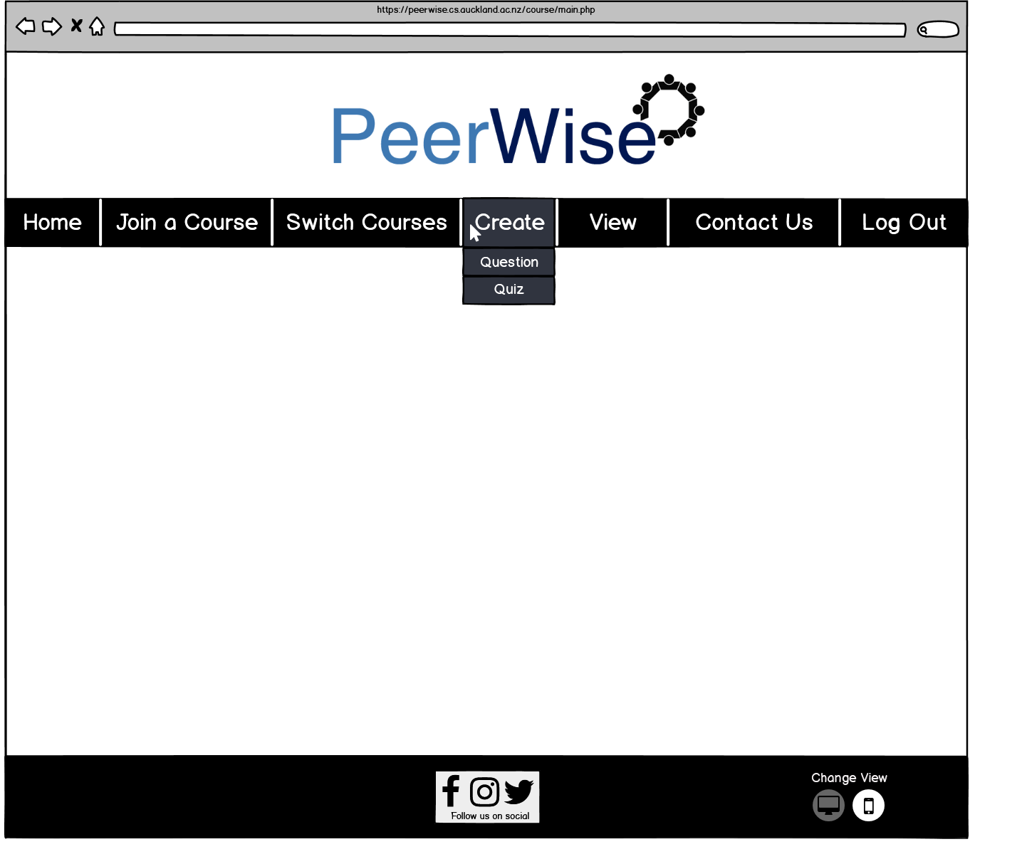

This ‘page’ shows the navigation bar drop-down options for the ‘Create’ tab. The user can navigate to the ‘creating question’ page by clicking on the Question option or they can navigate to the quiz creation page by clicking on the Quiz option. Since you need to answer questions to create a quiz Sarah and Matthew wouldn’t be using this drop-down option (or the drop-down option for creating questions) however, Ryan and Hans would definitely use these drop-down options.

**Navigation Bar View Options**

**Hans, Ryan, Sarah and Matthew (Use-case #14, Use-case #15**

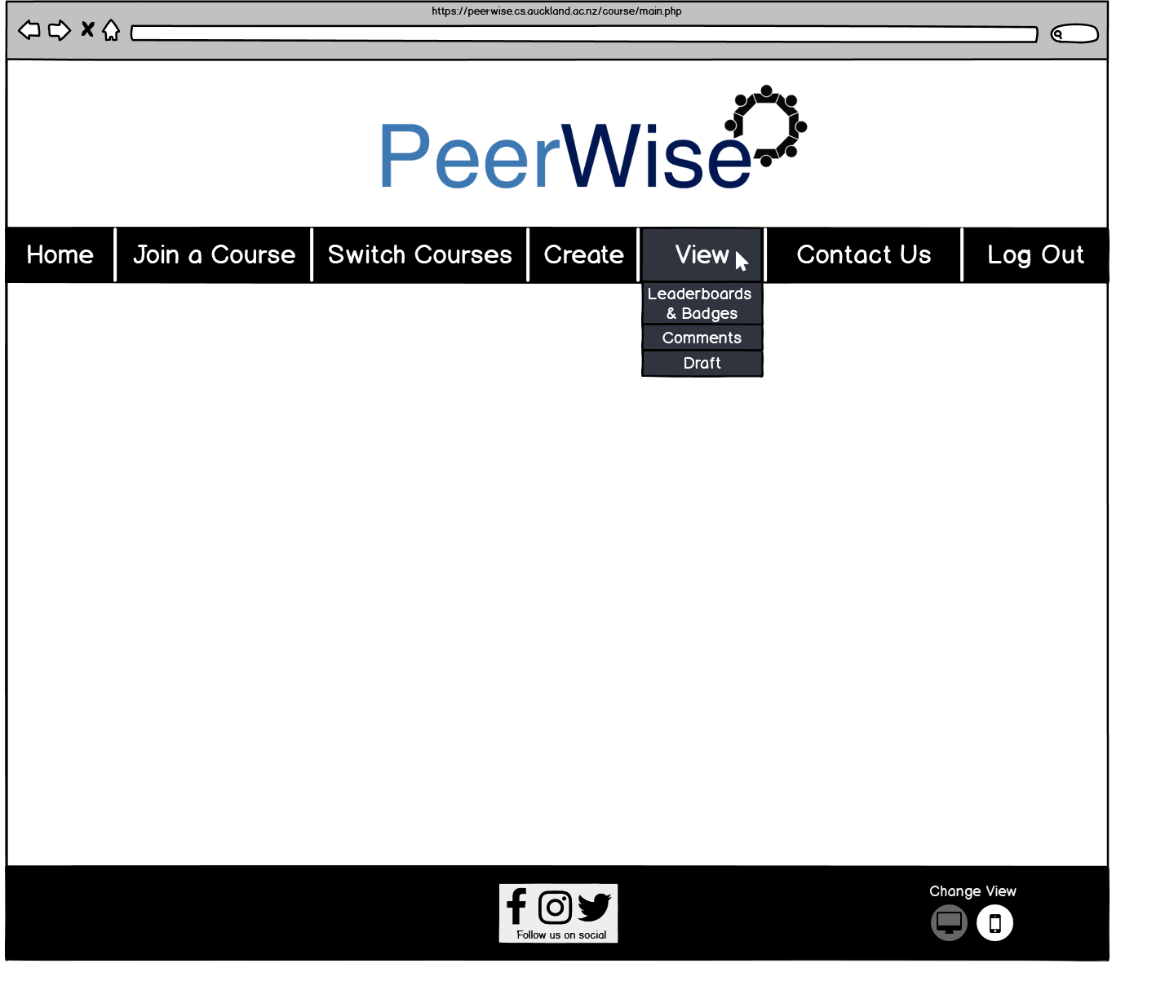

This page shows the drop-down options for the tab ‘View’ in the navigation bar. The first option ‘Leaderboards & Badges’ takes the user to the page when they can see the leaderboards and their badges. Sarah and Matt would use this option to see their classes progress and to gauge how much their class is interacting with/using PeerWise. Ryan would also use it to see how many badges he has got. The next option ‘Comments’ takes the user to the page where they can either view comments on their questions or comments they have created. Hans and Ryan would use this option as well since they likely will be making questions and comments. The last option ‘Draft’ only shows up if the user has a question saved as a draft. Clicking on this option shows the ‘editing question’ page where the user can edit their draft and see a preview of it before publishing it. Hans and Ryan would likely use this option since they may need to edit questions.

**Information Hierarchy**

We created the Information Hierarchy in Adobe XD.

The Adobe XD file that represents our Information Hierarchy can be found in our gitlab repository (<https://gitlab.ecs.vuw.ac.nz/onginyle/swen303-assignment-2>). The key bindings associated with the Information Hierarchy Adobe XD Prototype are stored in a text file in this repository.

**Reflection**  
**Prioritisation**

When creating PeerWises’ new design we accounted for all its functionality and features though we did prioritise and spent more work on the important functionality/features (e.g. creating questions, answering and rating questions). Because of this prioritisation we spent less time on designing pages for smaller features like viewing your comments/comments on your questions. Therefore, these pages designs were a bit more barebone than the main pages and could’ve been improved. For example, with the viewing comments page each comment could’ve been in their own box and the comments could’ve been laid out so there were multiple per row instead of one per row, e.g. (3x3) instead of (1x9). I think this would’ve utilised the pages space better as the design proposed had a lot of empty space on the sides of the page.

**Pros of our proposed design**

* A good colour scheme with a good variety of colours, it had primary and secondary colours, it was similar to PeerWise old colour scheme meaning it will be easier for users to adjust to the new design and the colours have high contrast.
* Very high (essentially 100%) task coverage. Our solution accounted for pretty much all tasks regardless of importance
* We made designs for pages that weren’t associated with any particular task, these pages related to the structure of the website or helped enable other pages to facilitate tasks. Having these pages gave a better overview of PeerWises’ system.
* A better logo. The new logo is undeniably better than the old logo since it is a higher resolution and in general looks a lot cleaner
* A navigation bar. A navigation bar is a component many websites use and for good reason to. Having a navigation bar means users can access key features/functions e.g. creating questions, joining courses and contacting PeerWise quickly and conveniently. It improves the flow of the website and accessibility of the websites components.
* Removed unnecessary information that PeerWise has. E.g. Removing the ability for users to change their answer after answering a question. Once a user sees the correct answer they shouldn’t be able to change it, doing so leads to confusing statistics and the user can just acknowledge that they chose the wrong answer and read the explanation if they don’t understand why instead of changing it. We also removed tags, a user could create and set a tag for questions they have answered but, since PeerWise already has topics (a way of categorising and classifying questions) and tags were not visible/useful at all in PeerWise current implementation we decided it was unnecessary functionality and therefore removed it.
* Visually our design doesn’t become stale with different background colours, text colours, graphs, icons and checkboxes however, the pages also have some consistency especially pages that have similar purposes (e.g. viewing a question page and viewing an answer page).

**Cons/Compromises of our proposed design**

* Our design only had one font ‘Comic Sans’. By using Balsamiq we only had access to this unprofessional font which means we had no font variety. Also despite Balsamiq having a large database of prebuilt components that we could use, these components had limited customisation. For example, Balsamiq has a window component but you can’t change the colour of the body of the window. This is why some of our components are white and black even though they may look better in a different colour. We used Balsamiq because it was easy to use but as a compromise we had lacking customisation at times.
* I think the backgrounds of our designs were a bit basic. What I mean by this is we used plain colours for all our components backgrounds which is fine for simple components like buttons but is underwhelming for section backgrounds. I think using images or colour gradients would make our website a bit more exciting and visually appealing.
* A more minor con to our proposed design is there were a lot of rectangles used whether that be buttons, tables, filter options, navigation bar options etc. I think having more variety in the shapes we used (e.g. rounded rectangles, circles etc.) would’ve been better
* One of the major cons of our design is it doesn’t cover/account for mobile users. The design caters for desktop/laptop users not mobile or tablet users. This is one of the larger cons of our website since it is likely quite a lot of PeerWise userbase access PeerWise on their phones. For example, Hans uses PeerWise on his phone so by not including a mobile-friendly version in our design we weren’t catering to his needs. We did include the option for users to switch views in our design in the footer however, this feature wasn’t functional. If I was to redo this project I definitely would’ve accounted for and considered mobile users.
* I also think we could’ve added/removed more of PeerWises’ functionality. When reflecting on our design I came across a number of things that we could’ve changed which likely would’ve made more sense for a website like PeerWise. These things were:  
  1. Instructors should have more power on PeerWise. Moderation is an important part of learning tools like PeerWise and our proposed solution doesn’t facilitate moderation very well. Though we did make comments not anonymous we could’ve done more to help instructors moderate their course. This could include instructors having the ability to delete any question (for example, if they feel the question is inappropriate) or instructors could be able to improve explanations/add comments without having to answer the question (this would be a time-saver for instructors and means the question statistics wouldn’t be skewed). Giving instructors more functionality means they could be more involved in the class and this would mean they would visit more of PeerWises’ pages (Sarah and Matthew aren’t involved in many of the pages of our proposed solution). Also, I think it would’ve been a good idea to remove the ability to improve the explanation of previous versions of a question. These versions are archived and should remain static (can’t be changed). In hindsight, leaving this in was an oversight on our part.

**Final thoughts**

Making our proposed solution made me realise that it is quite tricky to balance keeping the page designs fresh and interesting from one another but also making sure they aren’t all over the place. For example, using a colour scheme in our design enforced consistency but, also meant we had to use these colours in different ways (e.g. sometimes blue is used as a background colour, sometimes it is used as a text colour) to keep the user interested in using PeerWise. I also learnt that I find it much easier to create the layout of a page rather than the aesthetics. Stylising a page has a lot of different factors to it whereas the layout of the page is mainly about positioning and what content you decide to have on the page. That is why I think overall the layout of our solution is a stronger point than the aesthetics of it. Making this solution helped me understand PeerWises’ problem better. PeerWises’ problem was an outdated interface and design and comparing our design to their current design it can be easy to see why. They use icons that look like they come from the early 2000’s, an underwhelming logo, a very barebones navigation bar and unappealing aesthetics in general. Using the website myself and designing a new solution helped me see these flaws clearly.